Evaluating the Accuracy of HawkEye Ocean Color Imagery: Comparative Study of Satellite-Derived and In Situ Measurements

MITCHELL D. TORKELSON

A Prospectus submitted to the University of North Carolina Wilmington

in Partial Fulfillment of the Requirements for the

Degree of Master of Science in Marine Science

Center for Marine Science

University of North Carolina Wilmington

November 2023

Approved by

Advisory Committee:

Dr. Philip Bresnahan Date

Chair of Committee

Dr. Joanne Halls Date

Member of Committee

Dr. Qianqian Liu Date

Member of Committee

Table of Contents

Abstract 3

Introduction 3

Importance and Vulnerabilities of Coastal and Estuarine Environments 3

Expanding Horizons of Ocean Color Remote Sensing 4

Challenges of Remote Sensing in Coastal Biogeochemical Dynamics 5

Literature Review 6

Review of Ocean Color Missions 6

The SeaHawk/HawkEye 8

Atmospheric Correction 8

Bio-Optics 10

Pigment Algorithms 11

Spatial Heterogeneity 13

Practical Applications of Ocean Color Remote Sensing 14

Objectives 14

Materials and methods 15

Study site and in situ measurements overview 15

Satellite data acquisition and processing 20

In-situ remote sensing reflectance (Rrs) 21

Match-up analysis and accuracy evaluation 22

Preliminary Results 22

Academic Plan 31

References 32

# Abstract

This research explores the efficacy of HawkEye imagery in ocean color (OC) remote sensing, concentrating on the Cape Fear River Estuary (CFRE) in southeastern North Carolina. Coastal zones, while economically and ecologically valuable, face threats such as pollution and habitat destruction. OC remote sensing has revolutionized marine studies, notably in evaluating global phytoplankton concentrations. However, its accuracy diminishes in coastal regions due to their optically complex waters. Here, we describe our collection and analysis of sea-truthing data near Wilmington and Masonboro Inlet, comparing in-situ readings with data from various satellites like MODIS Aqua, Sentinel 3A/3B OLCI, and SeaHawk HawkEye. Notably, while most satellite/in-situ match-ups utilize 2-dimensional sea surface data, we employ an instrument capable of vertically profiling through the water column in order to consider 3-dimensional variability. Emphasizing the relationship between chlorophyll concentration, bathymetry, and water column mixing processes, the research ultimately seeks to assess the accuracy of satellite observations against direct aquatic measurements, driving improvements in marine conservation and resource management strategies.

# Introduction

## Importance and Vulnerabilities of Coastal and Estuarine Environments

Coastal and estuarine environments, where freshwater and marine realms converge, epitomize unique ecological and biogeochemical dynamism. These zones play indispensable roles in the life cycles of myriad aquatic species, serving not only as nursery grounds but also as critical habitats throughout various life stages (Beck et al, 2001; Nagelkerken, 2007; 2013; Sheaves et al., 2014).

Economically, coastal estuaries are indispensable. Their productivity underpins an estimated annual value of US$2.5 trillion, bolstering fisheries, aquaculture, and tourism sectors (Hoegh-Guldberg et al, 2015). For instance, coral reefs, beyond their ecological grandeur, serve dual roles: as formidable economic assets and as natural defenses against climatic adversities, shielding coastal areas and fostering other pivotal ecosystems like seagrass beds and mangroves (Barbier, 2014). Seagrasses act as biological bulwarks against wave energy, especially during low tide scenarios, and secure sediment with their extensive root networks, aiding in coastal erosion prevention (Fonseca and Cahalan, 1992; Hemminga and Nieuwenhuize, 1990). Furthermore, dune systems, through their root infrastructure, retain soil and counteract erosion, safeguarding numerous coastal assets, as well as providing a defense against coastal flooding (Doody, 2013; Barbier, 2014).

In the biogeochemical arena, estuaries excel as pivotal carbon reservoirs. These wetlands, some of the most productive ecosystems globally, sequester an estimated 5 to 87 Tg of organic carbon annually (Mcleod et al, 2011). Intriguingly, macroalgae, traditionally perceived as having minimal carbon burial potential due to their substrate preference, have been identified as significant contributors to global carbon burial, particularly when they colonize soft sediments (Macreadie et al., 2019).

Beyond their tangible values, estuarine environments are connected with local communities, offering recreational, cultural, and aesthetic significance (Ghermandi et al, 2011). Yet, alarmingly, these critical ecosystems are confronted with escalating anthropogenic pressures, from pollution and overfishing to climate perturbations and sea level rise. For instance, mangrove ecosystems have contracted by 35%, with some regions experiencing annual loss rates as high as 3.6%, mainly due to habitat destruction through human encroachment (Valiela et al, 2001; Kathiresan and Bingham, 2001). Analogously, many tropical warm-water coral reefs have witnessed precipitous declines of at least 50% over the past three to five decades (Hoegh-Guldberg et al., 2017). The subsequent degradation could have profound repercussions.

## Expanding Horizons of Ocean Color Remote Sensing

Encompassing approximately 70% of Earth’s surface, the oceans have traditionally presented considerable challenges for detailed study. The advent of satellite remote sensing technologies has revolutionized our comprehension of marine domains by delivering spatially extensive data on diverse oceanic attributes. Prior to this technological leap, oceanographic data predominately relied on point-measurements, such as those from ships or in-situ sensors, providing limited temporal and spatial snapshots, which were insufficient to capture mesoscale (10-300 km) variability (Carr et al., 2006). Remote sensing has augmented our capacity to discern sub-mesoscale features, like oceanic fronts and eddies, and even intricate micro-scale phenomena essential for marine ecological dynamics (Belkin, 2021). Ocean color (OC) remote sensing is the specific subdomain of remote sensing in which images of visible (and occasionally infrared) light are processed to provide estimates of water quality. Specifically, OC remote sensing has been instrumental in estimating global phytoplankton concentrations, thus informing chlorophyll a levels and primary productivity. While invaluable for open ocean studies, its accuracy wanes in coastal and estuarine regions due to interferences from optically active components such as colored dissolved organic matter (CDOM) and suspended sediments. These complexities, among other inherent to the dynamic coastal environment, impact the accuracy of remote sensing measurements in these regions. I will delve deeper into these intricate challenges and discuss possible mitigations later in this paper.

Photosynthesis plays a crucial role in the global carbon cycle. Astonishingly, marine ecosystems, with a mere phytoplankton biomass of around 1 Pg, contribute to 46% of global net primary production, approximating an annual mean of 48.5 Pg C yr-1 (Field et al., 1998). The foundational premise of OC remote sensing is the correlation between the intensity and spectral distribution of visible light reflected off the water surface and the underlying biogeochemical processes (Smith and Baker, 1978). Emphasis has been on chlorophyll a, a phytoplankton pigment, whose absorption in the visible spectrum modulates the ocean’s hue, turning it more greenish with rising concentrations (O’Reilly and Werdell, 2019). Since NASA’s maiden space-born OC sensor launch, Coastal Zone Color Scanner (CZCS), in 1978, there have been monumental strides in our grasp of phytoplankton distribution across oceanic expanses, facilitating monitoring from seasonal and interannual scales (Field et al., 1998; Behrenfeld and Falkowski, 1997; Delgado et al., 2015; Chen et al., 2022)

The purview of OC remote sensing has evolved; enhanced technology now accurately quantifies other marine constituents like total suspended matter, CDOM, and particulate inorganic carbon. Additionally, its applications now span diverse marine habitats, monitoring environmental perturbations in both pelagic and coastal zones (Dierssen and Randolph, 2012). Recent studies have introduced innovative platforms for OC data analysis that synergize radiative transfer simulations with machine-learning methods to increase the accuracy of OC measurements (Fan et al., 2021), while others have harnessed the power of deep learning to estimate near-blue UV bands reflectance from visible bands provided by OC satellites (Wang et al., 2021). Additionally, though hyperspectral OC radiometry is coming soon with the launch of PACE, the scope of this study will focus on multispectral satellite sensors.

## Challenges of Remote Sensing in Coastal Biogeochemical Dynamics

Coastal regions, covering just 7% of the oceanic area, are crucial nodes in the biogeochemical processes underpinning marine productivity (Tran et al., 2019). Carbon in the biosphere is distributed among atmospheric, oceanic, and terrestrial reservoirs. Specifically, coastal waters bridge terrestrial and oceanic reservoirs, channeling terrestrial carbon from soils to rivers and eventually to the coasts as dissolved inorganic carbon (DIC), dissolved organic carbon (DOC), and particulate organic (POC) and inorganic (PIC) carbon (Tran et al., 2019). These coasts contribute 75–90% of global sediment from rivers and 15% of marine primary production, making them biogeochemical transformation hubs (Loisel et al., 2013). Suspended particulate matter (SPM), a composite of organic and inorganic constituents, modulates light penetration and nutrient dynamics, thus influencing phytoplankton production. POC, a central component of the oceanic carbon cycle, comprises of living materials such as heterotrophic bacteria, phytoplankton, and zooplankton as well as detritus. The quantity of POC is a strong indicator of productivity in the euphotic (sunlit) zone. Over the years, bio-optical algorithms have been developed to estimate concentration of POC in the oceanic layers using OC radiometry. However, understanding coastal contributions to the global carbon cycles remains challenging due to their complexity, making it imperative to elucidate the roles and interactions between terrestrial and aquatic, pelagic and benthic, and organic and inorganic constituents within the marine biogeochemical cycles (Bauer and Druffel, 1998; Hedges et al., 1997; Hedges, 1992, Schlünz and Schneider, 2000). Traditional data collection methodologies, including oceanographic cruises and in-situ time-series, are constrained by spatial and temporal limitations, coupled with substantial financial and labor costs. Conversely, remote sensing promises expansive spatial and temporal coverage, yet grapples with challenges related to depth resolution and accuracy, revisit times, cloud coverage, algorithm development, etc., necessitating in situ validation (Miller and McKee, 2004; Doxaran et al., 2009; Vanhellemont and Ruddick, 2014, Ody et al., 2016).

Coastal remote sensing is mired in complexities owing to the diverse and dynamic nature of the coastal environment. Phenomena such as photon reflection from adjacent landmasses and ocean floor reflection are significant impediments to the accurate estimation of marine bio-optical properties (Loisel et al., 2013). Another complex aspect of coastal dynamics is sediment resuspension in littoral zones. Such resuspension events not only pose difficulties for remote sensing but are also crucial for understanding sediment transport and nutrient cycling, Terrestrial fluxes from riverine sources, instrumental in influencing nutrient gradients, light availability, phytoplankton activity, and pollutant dissemination, remain inadequately quantified (Häder and Gao, 2015). Effective monitoring of SPM is vital for deciphering sedimentary dynamics and facilitating ecologically informed coastal management. Factors shaping SPM distribution at river mouths, from fluvial characteristics to seasonal changes and coastal conditions, are often overlooked due to limited data. Furthermore, the coastal milieu, replete with reflective minerals and high concentrations of particulate organic matter, can obfuscate satellite-derived signals, confounding atmospheric corrections and bio-optical algorithm outputs (IOCCG, 2000; 2006). Intermittent cloud cover further exacerbates this by misidentifying turbid zones as clouded regions, further reducing data availability (Loisel et al., 2013). The pronounced heterogeneity inherent to coastal zones amplifies these complications. Collectively, these challenges accentuate the need for refined methodologies and enhanced tools tailored to coastal remote sensing.

# Literature Review

## Review of Ocean Color Missions

NASA’s foray into Earth observation can be traced back to the 1960s with initiatives like TIROS and NIMBUS, primarily oriented towards meteorology. The spark for ocean color (OC) observations was kindled when a 1970 publication in Science revealed the potential of airborne measurements to discern near-surface Chl concentrations (Clarke et al., 1970). This revelation galvanized a burgeoning community in marine optics and ocean biology/ecology, aspiring to harness the potential of satellite-based OC observations.

The Coastal Zone Color Scanner (CZCS), operational from 1978 to 1986, heralded a new era in marine remote sensing. As a singular OC instrument aboard the Nimbus-7 satellite, it boasted six bands, emphasizing wavelengths centered on 443, 520, 550, 670, and 750 nm and a thermal IR band at 11.5 um (NASA). The Nimbus Experiment Team supported the CZCS initiatives by developing algorithms for atmospheric correction (AC; see explanation below) and bio-optical data product derivation (Gordon et al., 1983). McClain et al.’s (1984) assessment of these algorithms, juxtaposing in situ Chl measurements with CZCS-derived data values across the Gulf Stream, revealed remarkable congruence. Although Nimbus-7 sensors were considered a proof-of-concept, collaborative endeavors with the Skidaway Institute of Oceanography yielded SEAPAK, a software suite for CZCS data manipulation, consequently enticing a wider research community. SEAPAK was eventually superseded by the SeaWiFS Data Analysis System (SeaDAS) (Baith et al., 2001).

The Sea-viewing Wide Field-of-view Sensor (SeaWiFS), aboard the OrbView-2 spacecraft (formerly SeaStar) from 1997 to 2010, incorporated 8 distinct bands centered on the 412, 443, 490, 510, 555, 670, 765, and 865 nm wavelengths collected data with a 1100 m spatial resolution (NASA). With a swath width of 2,801 km, it was capable of daily revisit times. In response to CZCS’s sensor attrition challenges, NASA innovated calibration methodologies for the SeaWiFS mission, including deploying the Marine Optical Buoy (MOBY) off Lanai, Hawaii, and pioneering lunar calibration for ongoing sensitivity assessments (Barnes et al., 2001). These novel calibration approaches have since been adapted to support NASA OC missions (Franz et al., 2012).

The Moderate Resolution Imaging Spectroradiometer (MODIS), operating aboard the Aqua and Terra satellites since 1999, supports diverse environmental inquiries with its 36 spectral bands ranging from 412 nm to 14.3 μm. Of these, nine are quintessential for OC studies, centered on wavelengths 412, 443, 488, 531, 547, 667, 678, 748, and 869 nm, at 1000 m spatial resolution, 2330 km swath width, and 1–2-day revisit times, with the MODIS-Aqua proving more robust for marine applications due to calibration discrepancies with MODIS-Terra (NASA; Franz et al., 2008; Kwiatkowska et al., 2008).

The Visible Infrared Imaging Radiometer Suite (VIIRS) sits aboard the Suomi National Polar-orbiting Partnership (SNPP) spacecraft which launched in 2011, and later on the Joint Polar Satellite System-1 (JPSS-1) in 2017 and JPSS-2 in 2022. The VIIRS instruments were designed with 22 spectral bands ranging from 412 nm to 12.05 μm, of which, those centered at wavelengths 415, 445, 490, 555, 673, 746, and 865 nm were particularly tailored for oceanic studies. VIIRS ensures consistent global coverage due to its daily revisit cycle and approximately 3,000 km swath width and a spatial resolution of 750 m of nadir pixel size (NASA, VIIRS)

Under the European Space Agency (ESA) Copernicus initiative, the Sentinel-3 satellite series was launched with two active and two prospective missions. The Sentinel-3A and Sentinel-3B satellites are equipped with duplicates of the Ocean and Land Colour Instrument (OLCI) that features 21 spectral bands ranging from 400 to 1020 nm and provides 300 m spatial resolution. With a 1,270 km swath width, a single satellite offers global coverage in 3-4 days, reducing to 1-2 with both satellites in operation (NASA; Sentinel Online).

The Operational Land Imager (OLI), aboard the Landsat-8 satellite since 2013 and Landsat-9 since 2021, offers 30 m spatial resolution with spectral bands at 440, 475, 550, 655, 865, 1370, 1610, 2200, and a panchromatic band at 590 nm (US Geologic Survey, n.d.). While primarily designed for terrestrial inquiries, OLI’s bands span the blue to green region of the visible spectrum and include two bands in the near-infrared (NIR) to shortwave IR (SWIR), making it compatible with the AC process, and subsequently has been proven to be useful in OC science (Franz et al., 2015; Vanhellemont and Ruddick, 2014; 2015).

The Sentinel-2 mission, initiated with the launch of Sentinel-2A in 2015 and complemented by Sentinel-2B in 2017, consists of two identical satellites, both outfitted with the Multispectral Instrument (MSI). This sensor measures in 13 spectral bands, ranging from 443-2190 nm, with central wavelengths at 443, 490, 560, 665, 705, 740, 783, 842, 865, 945, 1375, 1610, and 2190 nm. When functioning collaboratively, these satellites deliver a global revisit frequency of 5 days with a swath width of 290 km. They achieve a spatial resolution of 10 m in the 4 visible and NIR bands, 20 m in the 6 red-edge and SWIR bands, and 60 m in the 3 bands dedicated to atmospheric correction (Sentinel Online).

In summary, there are multiple retired and active multispectral satellite missions designed for a range of spatial scales, revisit times, and scientific topics. NASA’s early ventures into Earth Observation began in the 1960s, with the 1970s seeing the birth of OC observations. The CZCS in the late 70s marked a significant advancement in marine remote sensing. This momentum continued with the launch of SeaWiFS in the 90s and later with MODIS in the late 90s. The 2010s witnessed the introduction of the VIIRS on multiple platforms, Europe’s Sentinel-2 and 3 series with OLCI and MSI, respectively, as well as OLI on Landsat-8, which has applicability in OC science.

## The SeaHawk/HawkEye

The 2018-initiated SeaHawk CubeSat mission, supported by Gene Feldman and NASA’s Ocean Biology Processing Group (OBPG), epitomizes a transformative paradigm in OC remote sensing by pioneering cost-effective Earth Observation (EO) endeavors. The mission’s core instrument, the HawkEye sensor, created by Alan Holmes with Cloudland Instruments, redefines miniaturization in OC instruments.

Distinct from traditional EO satellites, SeaHawk’s design emphasizes efficiency. Its compact and lightweight stature of 10 x 10 x 30 cm3 (3U) and 3 kg weight stands in stark contrast to Orbview-1’s larger 50 x 50 x 200 cm3 frame and 309 kg weight. Furthermore, its rapid development span of two years and the comparatively modest budget of $4 million is significantly leaner compared to OrbView-1’s decade-long, $100 million undertaking (<https://www.eoportal.org/satellite-missions/seahawk-1#seahawk-1-cubesat-ocean-color-mission>).

Notably, SeaHawk’s efficiency doesn’t sacrifice performance. The HawkEye instrument, despite its condensed 1U size (10 x 10 x 10 cm3), embodies an advanced sensor configuration with 4 linear arrays and 8 bands akin to SeaWiFS. It achieves an impressive linear spatial resolution of 120 m, an eightfold enhancement from SeaWiFS 1100 m. When considering the area, this translates to a 70-fold improvement, as approximately 70 pixels of 120 x 120 m2 can fit into a single 1000 x 1000 m2 pixel of SeaWiFS. This highlights the significance of the HawkEye’s advancement, especially given the ocean’s inherent darkness, wherein up to 90% of light detected in some bands over ocean scenes comes from other, non-ocean sources such as atmospheric particles. Thus, maximizing the signal-to-noise ratio (SNR) is paramount (Holmes et al., 2018).

HawkEye, with its superior spatial resolution SeaWiFS-class spectral quality, bridges the gap between open and coastal ocean remote sensing. Its spectral alignment with SeaWiFS ensures data consistency, but its nimble, cost-effective design, rooted in CubeSat technology and off-the-shelf commercial components, signifies technological progress. Thus, HawkEye doesn’t supplant missions like SeaWiFS; it augments them, offering a more granular perspective of intricate marine ecosystems. With the promise of scalability through potential constellation launches, SeaHawk delineates a promising trajectory for affordable, high-resolution marine monitoring endeavors (Jeffrey et al., 2018)

## Atmospheric Correction

Atmospheric correction (AC) serves as a crucial computational step for ensuring that bio-optical models and pigment algorithms harness oceanic conditions without atmospheric interferences. Optical remote sensing is heavily influenced by atmospheric elements, altering the spectral attributes of the radiation received by remote sensors. Since the radiation travels through the atmosphere twice – once from the sun to the target and back to the image sensor – events like absorption and scattering at varied wavelengths modify the observed signal. Up to 90% of this detected signal might arise from atmospheric factors, emphasizing the importance of accurately extracting the inherent aquatic signal (IOCCG, 2010).

Before AC, satellite sensors detect a top-of-atmosphere (TOA) signal comprising photons from both aquatic and atmospheric origins. The AC process distills the water leaving radiance (Lw)from the total radiance (Lt) registered by the satellite sensor at the TOA. This extraction is vital, considering the intricate interactions between solar radiation and Earth’s atmosphere, which influences the light’s trajectory and characteristics reaching satellite sensors. Inaccurate AC can severely compromise the veracity of OC mission outputs.

The observed upwelling radiance (Lu) is an amalgamation of:

1. La, atmospheric contribution, from solar radiation scattering by atmospheric gases and aerosols.
2. Lr, surface-reflected radiance, depicts sunlight reflected by the water's surface.
3. Lw, water-leaving radiance, represents the light that has permeated the ocean surface, interacted with marine constituents, and scattered upwards.

Conceptually, this relationship is:

$$\begin{aligned}L_{u}=L_{a}{ + L}_{r}+L_{w} \#\left(1\right)\end{aligned}$$

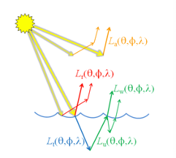

Figure 1: A model of the factors contributing to the observed upwelling radiance above the sea surface (Mobley, Ocean Optics Web Book: Atmospheric Correction, The Atmospheric Correction Problem).

$L_{u }$ (Figure 1) highlights the diverse processes that contribute to the TOA radiance. La can be dissected into elements such as Rayleigh scattering ($L_{R}$) and aerosol contributions ($L_{A}$). Rayleigh scattering pertains to scattering caused by atmospheric molecules in and includes the reflectance from the sea surface (Lsky­). Aerosols influence both scattering and absorption, combining the contributions from aerosol ($L_{a}$) and aerosol-gas interactions ($L_{aR}$). Sun glint ($L_{g}$) is sunlight reflected off water surfaces, while whitecaps ($L_{wc}$) represent sunlight reflection from the ocean’s foam and whitecaps. Transmittance factors, both direct ($T$) and diffuse ($t$), modulate these contributions. Direct transmission denotes the light fraction passing through the atmosphere without scattering, whereas diffuse transmission relates to radiation undergoing multi-directional scattering. While there are additional intricacies, such as gaseous transmission and polarization correction, these nuances extend beyond the scope of this study. However, acknowledging their presence and potential impact on the TOA radiance is essential (Mobley, 2020).

Classical algorithms like Gordan and Wang’s (1994) leverage the “black pixel” postulate for the near-infrared (NIR) band, presuming NIR wavelengths to have negligible oceanic contributions. This assumption allows algorithms to assign the full NIR signal to atmospheric sources which, in turn, enables estimation of atmospheric properties which are then applied to other wavelengths. While efficacious for oligotrophic waters, this assumption fails in optically complex waters like coastal and turbid regions where the aquatic contribution to the NIR signal might differ from zero (Siegel et al., 2000; Ruddick et al., 2000; Stumpf et al., 2003). Innovative correction strategies for such waters have emerged, either iteratively adjusting NIR radiance with parameters like chlorophyll a or sediment concentrations (Lavender et al., 2005; Siegal et al., 2000) or employing models concurrently solving aerosol and backscattering properties (Ruddick et al., 2000). Modern methodologies also utilize shortwave infrared (SWIR) bands, enhancing AC in optically complex waters (Wang et al., 2007; 2011; Hu et al., 2012).

## Bio-Optics

OC remote sensing harnesses our knowledge of bio-optical properties to illuminate facets of marine ecosystems and biogeochemical dynamics. These properties delineate how light interacts with waterborne constituents, such as phytoplankton, suspended sediments, and CDOM Grounded in bio-optical principles, specialized pigment algorithms interpret radiometric data to deduce attributes such as phytoplankton concentration, non-algal particles, and CDOM (Werdell et al., 2018). This analytical approach has deepened our knowledge in key research domains, including carbon cycling (Allison et al., 2010; Siegel et al., 2014), oceanic productivity (Saba et al., 2011), and phytoplankton diversity (Westberry et al., 2016).

Two fundamental optical property categories underpin bio-optical studies: Inherent Optical Properties (IOP) and Apparent Optical Properties (AOP). IOPs are inherent to the water and its constituents, independent of the incidence angle or intensity of light. They encompass the absorption A(λ), scattering B(λ), and transmittance T(λ) characteristics of light within the medium, where “(λ)” denotes their wavelength dependence. Conversely, AOPs provide a more empirical perspective, capturing how water appears by merging ambient light conditions with the bio-optical framework. A notable AOP is the Remote Sensing Reflectance (Rrs), which standardizes the water-leaving radiance, enabling consistent comparisons across diverse light conditions. While IOPs provide a foundation by illustrating micro-level light interactions with water and its components, AOPs emerge from these interactions and consider the broader environment, such as sunlight angle and water’s overall appearance.

One of the most widely used relationships in bio-optics links absorption and backscattering to Remote Sensing Reflectance (Rrs). This synergy between IOPs and AOPs facilitates researchers in extracting vital parameters from satellite-derived OC data, thereby providing insights into marine biogeochemistry and ecosystem dynamics (Mobley, 2020).

$$\begin{aligned}R_{rs} \frac{f}{Q}\frac{b\left(\right)}{a\left(\right)}\#\left(2\right)\end{aligned}$$

## Pigment Algorithms

Pigment algorithms serve as computational frameworks that convert remote sensing reflectance Rrs(λ) into geophysical variables, prominently chlorophyll a (Chl) concentration. These variables are essential proxies for assessing marine ecosystem health, underpinning endeavors in fisheries management, water quality monitoring, and recreational activities (IOCCG, 2008). Nonetheless, a salient constraint arises from satellites predominantly capturing surface waters, potentially misrepresenting sub-surface biomass distributions (Hill and Cota, 2005). Two primary algorithmic archetypes for deriving Chl from Rrs(λ) are empirical and semi-analytical algorithms (SAAs).

Empirical OC algorithms hinge on the statistical nexus between Rrs(λ) and concurrent, collocated in-situ Chl observations. Pioneered by Clark et al. (1970), renowned models such as OC2, OC3M, and OC4 have since emerged. Specifically, the OC4 algorithm, tailored for SeaWiFS, computes Chl using the ratio of blue (Rrs(443), Rrs(490), Rrs(510)) to green light (Rrs(555) reflected from the sea (O’Reilly et al., 1998; 2000) (Figure 2):

$$\begin{aligned}Chl={10}^{\left(0.366-3.067X+1.930X^{2}+0.649X^{3}-1.532X^{4}\right)}\#\left(3a\right)\end{aligned}$$

$$\begin{aligned}X=\log_{10}\left(\frac{\max\left[{Rrs}_{443},{Rrs}_{490},{Rrs}_{510}\right]}{{Rrs}_{555}}\right)\#\left(3b\right)\end{aligned}$$

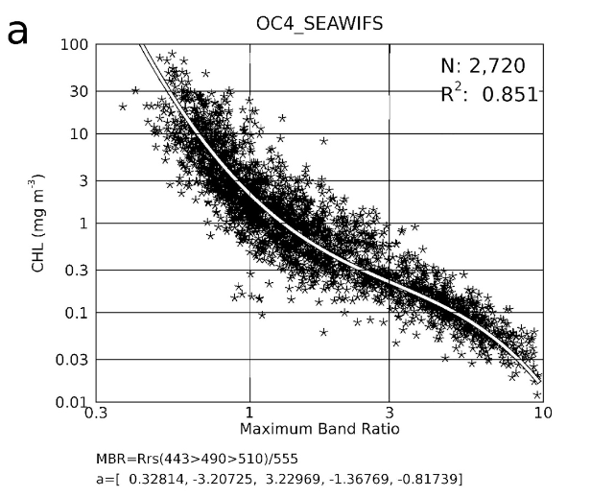

Figure 2: High chlorophyll concentrations are associated with low blue over green reflectance. Relatively clear water would be to the right on the x-axis (O’Reilly and Werdell, 2019).

Rooted in robust datasets of paired in situ Chl and Rrs(λ) measurements, this third-order polynomial model, however, remains vulnerable to calibration disparities, atmospheric correction, or other noise perturbations (McClain, 2009; Dierssen, 2010). Although proficient in Case 1 waters—where phytoplankton predominantly influence optical properties—empirical algorithms often falter in Case 2 coastal waters. Here, other optically active constituents like CDOM and TSM introduce complexities and can skew results (Sathyendranath et al., 1999; Prieur and Sathyendranath; Dierssen et al., 2006; Schofield et al., 2004; Dowel, 2012).

Alternative empirical methodologies include Rrs(λ) line-height models (Hu et al., 2012), red-edge ratio linear methods (Moses et al., 2012), and machine learning techniques such as artificial neural networks (Doerffer and Schiller, 2007). NASA’s Ocean Biology Processing Group notably employs the OC3/OC4 band ratio algorithms across OC missions, with the NASA bio-Optical Marine Algorithm Dataset (NOMAD) (O’Reilly et al., 2000; NASA Ocean Color; Werdell and Bailey, 2005). A pivotal enhancement came in 2014, integrating the OC3/OC4 algorithm with the ocean color index (OCI) to refine Chl estimations in oligotrophic waters (Chl < 0.3 mg/m3) (Franz, 2014).

The interference of CDOM and TSM on the normalized water-leaving radiance (nLw) complicates accurate Chl determinations via empirical algorithms (IOCCG, 2006). Mitigating this, SAAs have emerged, amalgamating in situ IOP databases specific to specific aquatic regions with radiative transfer theoretical frameworks (Lee et al., 2002; Maritorena et al., 2002; Sathyendranath et al., 2001). Delineating IOPs, SAAs offer insights into the total absorption and backscattering coefficients (a(λ)), bb(λ), respectively) of water (aw(λ), bw(λ)) and a diverse range of marine constituents, including phytoplankton (aph(λ), bph(λ)), detrital matter or non-algal particles (ad(λ)), bd(λ)), and CDOM (aCDOM(λ) or ag(λ)) (IOCCG, 2006):

$$\begin{aligned}R_{rs}\left(\right)=\frac{f}{Q}\frac{b_{w}\left(\right)+b_{ph}\left(\right)+b_{d}\left(\right)}{a_{w}\left(\right)+a_{ph}\left(\right)+a_{d}\left(\right)+a_{CDOM}\left(\right)}\#\left(4\right)\end{aligned}$$

In summary, pigment algorithms convert Rrs(λ) measurements into geophysical variables like Chl concentration, essential for assessing marine ecosystem health. While satellite capture primarily surface waters, potentially overlooking sub-surface biomass, two main algorithm types derive Chl from this reflectance: empirical and semi-analytical algorithms. Empirical algorithms, like OC4, are based on the statistical relationship between reflectance and in-situ Chl observations, but they may struggle in coastal waters due to complexities introduced by other constituents. Conversely, SAAs combine in-situ inherent optical properties databases with radiative transfer theories, providing insights into water’s total absorption and backscattering coefficients and a range of marine components.

## Spatial Heterogeneity

Marine ecosystems are significantly influenced by environmental heterogeneity, impacting their dynamics across spatial scales ranging from microhabitats to expansive regions. A key determinant of this variability is the distribution of planktonic microorganisms, modulated by the physical, chemical, and biological properties of the surrounding fluid medium (Sverdrup, 1953; Neill, 1994; Siegel et al., 2002). On smaller scales, vertical stratification in aquatic systems arises from physical factors such as turbulent mixing, thermal gradients, light penetration, and nutrient dispersion, as well as biological factors like depth-stratified zooplankton grazing (Pingree et al., 1976; Seymour et al., 2004). Larger organisms like zooplankton respond to medium to large-scale spatial heterogeneity, navigating due to food concentration gradients and predation threats (Masson et al., 2004). This spatial heterogeneity profoundly impacts population dynamics, community assemblages, and overall ecosystem stability (Mehner et al., 2005). Additional complexities arise in coastal waters, where river discharge and bathymetry gradients can amplify habitat heterogeneity, leading to algal bloom variability (Rabalais et al.,1996).

Understanding the vertical distribution of algal biomass becomes paramount, given its direct association with ecological dynamics. The vertical movement of algae significantly influence surface chlorophyll a (Chl-a) concentrations, underscoring that surface-only assessments can sometimes misrepresent the true biomass dynamics (Cao et al., 2006; Lee et al., 2012). Traditional assessment techniques, like associating surface Chl-a concentrations with water column-wide phytoplankton biomass or adopting the Gaussian vertical profile approach, may oversimplify the intricate nature of coastal ecosystems (Shi et al., 2014). The vertical inhomogeneity of phytoplankton complicates Chl-a analysis and depth-specific modeling (Silulwane et al., 2001; Xue et al., 2017). This calls for the evolution of strategies to accurately quantify algal biomass across vertical tiers. Advanced remote sensing techniques, which segment the water column based on the euphotic zones, hold promise in addressing these challenges, ensuring a comprehensive understanding of spatial and temporal distribution of algal biomass systems (Mobley and Sundman, 2008).

## Practical Applications of Ocean Color Remote Sensing

The utility of OC remote sensing stretches beyond the mere observation of marine phenomena. It plays a vital role in the operational and strategic management of marine and coastal resources by offering a synoptic view that is otherwise challenging to obtain through in-situ measurements.

OC products, particularly Chl concentration, offer invaluable insights into primary production and phytoplankton abundance and productivity (Xi, H., 2021). These metrics indirectly illuminate the marine carbon cycle, given phytoplankton’s central role in carbon sequestration via photosynthesis (Xi, H., 2021). Moreover, remote sensing of water’s optically active constituents offer insights into water quality, as each wavelength has a unique spectral signature. Variations in absorption and color changes, influenced by elements like phytoplankton and CDOM, can indicate the presence of pollutants, suspended sediments, or DOM, affecting marine life and human activities (Wagh et al., 2020). Additionally, given the ecological disruptive and sometimes toxic nature of harmful algal blooms (HABs), their expeditious identification via OC data proves imperative for public health advisories, fisheries management, and ensuring the safety of recreational activities in affected waters (Shen et al., 2012).

The health and distribution of phytoplankton, as determined through OC products, give insights into the presence and abundance of zooplankton, which form the base of the marine food chain. By integrating this data with sea surface temperature and other oceanographic parameters, fisheries are better able to forecast fish stock movements and spawning events (Mutia and Sailale., 2021). Remote sensing not only bolsters the management and surveillance of marine protected areas (MPAs) but also complements field surveys, enhancing global conservation efforts (Kachelriess et al., 2014). Such continuous surveillance of marine ecosystems allows policymakers to make informed decisions on coastal infrastructure development, resource allocation, and conservation strategies (Hedley et al., 2016).

The coastal and estuarine environments, characterized by their rich biodiversity and productivity, support a significant portion of the global human population. These zones deliver diverse ecosystem services but confront escalating threats form anthropogenic activities, climate change, and pollution (He and Silliman, 2019). In this context, the pertinence of OC remote sensing becomes even more pronounced. In essence, ocean color remote sensing acts as the eyes in the sky, continuously watching over our valuable coastal and estuarine environments, guiding us in their stewardship, and ensuring their health and productivity for generations to come.

# Objectives

Given the improvements offered by the HawkEye imagery, combined with the necessity for in-situ validation in ocean color remote sensing, our research is grounded in the aspiration to collect 3-dimensional sea-truthing data in nearby waters. Such endeavors are crucial, not only in the validation process but also in assessing the complex variability of local water quality parameters in three dimensions. This provides a unique opportunity for a nuanced matchup between satellite and in-situ sensors in waters that are optically complex and of local significance. With this foundational prospective, we delineate our objectives as follows:

1. Plan field missions to collect contemporaneous, collocated in situ and remotely sensed imagery. In situ data will include [blank] using the Sea Sciences Acrobat in order to provide 3D coverage.
2. Analyze high-resolution OC imagery from HawkEye, MODIS, OLCI, and OLI spanning the Cape Fear River Estuary that overlaps temporally with R/V Cape Fear in-situ data collection cruises. This imagery will serve as a basis for evaluating HawkEye’s performance against in-situ water parameter measurements captured by the Acrobat and a handheld spectroradiometer.
3. Investigate the spatial variability of Chl concentrations within the CFRE. This will entail integrating in situ and satellite-derived measurements, targeting regions proximate to Wilmington and the mouth of the Masonboro Inlet. Analyze the intricacies captured by HawkEye that were missed by the lower resolution satellites.
4. Execute a comprehensive matchup analysis, juxtaposing satellite observations with their in-situ counterparts to evaluate the accuracy and reliability of satellite-derived measurements. This assessment will leverage statistical metrics such as R2, RMSD, MAPD, CV, Bias) to quantify discrepancies.
5. Synthesize and disseminate the research outcomes through a prominent scientific journal. The methodologies and data sets will be made openly available to be shared with the broader scientific community to promote HawkEye’s capabilities and encourage its increased utilization in related studies.

# Materials and methods

## Study site and in situ measurements overview

We conducted this study in two regions of the Cape Fear River Estuary (CFRE) in southeastern North Carolina (Figure 3). On May 3, 2023, our study spanned the Cape Fear River (CFR) near Wilmington (34.0836, -77.9331) (Figure 4). This date served as a technical evaluation for the Acrobat instrument, a versatile marine research platform developed by Sea Sciences Inc. (Figure 5). Despite its lightweight frame (approximately 30 lbs. without instrumentation), the instrument accommodates standard research tools and facilitates real-time data acquisition. We paired the Seabird SBE 25 plus Sealogger CTD, with a suite of auxiliary sensors such as Seabird SBE 4 Conductivity sensor, Seabird 43 Oxygen sensor, Seapoint Chlorophyll Fluorometer, Seapoint Ultraviolet Fluorometer, and Seapoint Turbidity Meter. The outcome of this assessment yielded some valuable data, albeit limited in quantity.

The primary emphasis of the study and analysis was the subsequent sampling date, May 5, 2023, which targeted the entry point of the Masonboro Inlet near Wrightsville Beach (34.181, -77.798) (Figure 4). This inlet, approximately 0.2 miles wide, lies to the east of Wilmington, NC, connecting the Intracoastal Waterway and Greenville Sound to the Atlantic Ocean via Shinn Creek and separating Masonboro Island Reserve from Wrightsville Beach. Historically, during the Civil War, Masonboro Inlet served as a primary route for blockade runners, offering them shelter behind the barrier islands before they accessed Wilmington and the CFR. Today, the inlet boasts two beaches and is marked by two rock jetties extending into the ocean, which allows it to be navigable for various vessel sizes, despite potential shoaling present in the broader Cape Fear (CF) coastal region (capefear-nc.com).

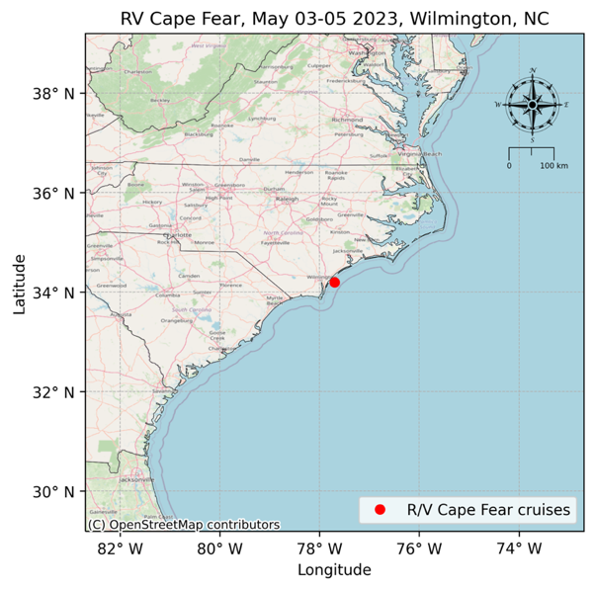

Figure 3: Study area in southeastern North Carolina.

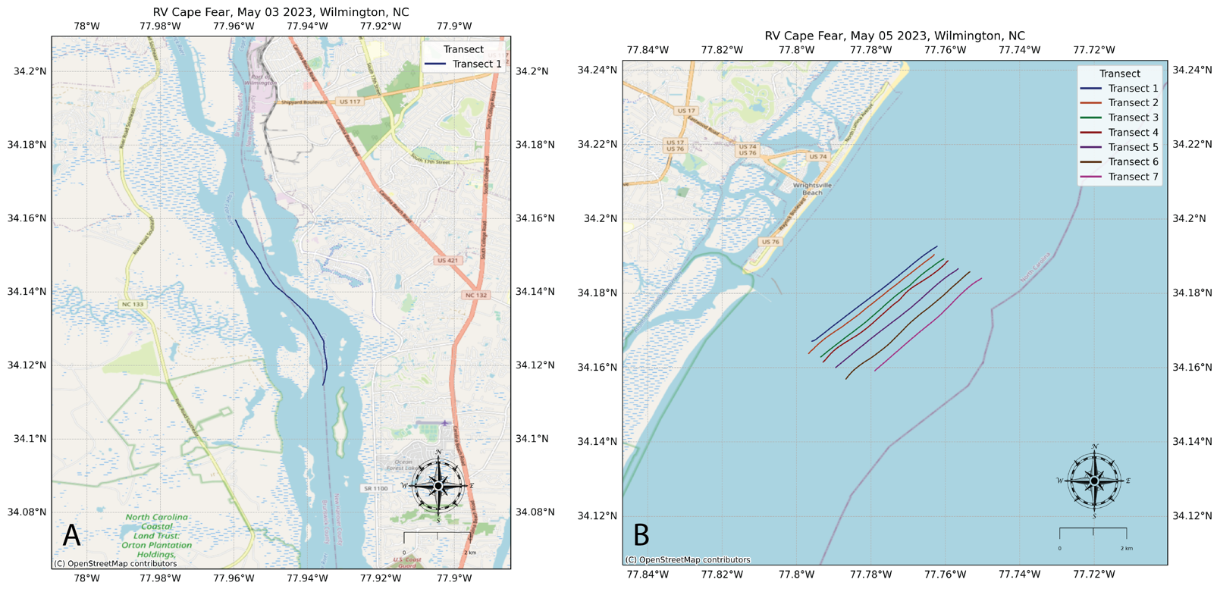

Figure 4: In-situ sampling transect locations. A) Cape Fear River, B) Mouth of the Masonboro Inlet

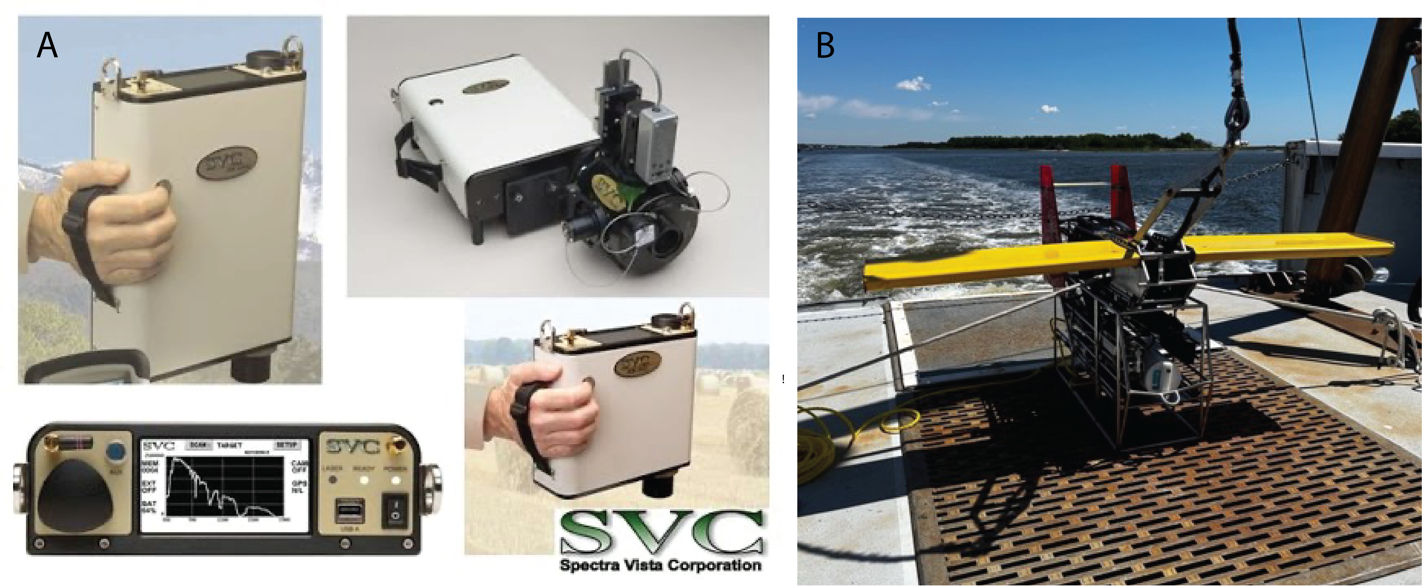

Figure 5: In-situ measuring instruments. A) HR-512i Handheld Spectroradiometer, B) Acrobat with auxiliary sensors.

The shoreface zone in this area connects the continental shelf with the subaerial coastal plain and acts as a buffer against oceanic forces while also facilitating the exchange of materials between land and sea. This area is part of Onslow Bay, a high-energy, wave-dominated, microtidal shelf environment with a mean tidal range of about 1 m, and an average wave height of approximately 0.78 m with a period of 7.88 s (Thieler et al., 1995). Nestled within this bay, Wrightsville Beach, a distinctive low-lying, transgressive barrier island, stands out for its high-density development, populated with numerous single-family homes, duplexes, hotels, and condominiums. The shoreface plays a crucial role in sediment dynamics, influencing beach morphology, with sedimentary processes considerably molded by its geological attributes. The wave climate is characterized by waves approaching mainly from the northeast during winter and southeast during summer. In conjunction with storm waves from various directions, this results in a pronounced southward sediments drift (Jarrett, 1977). Considering the erosion of existing sediments and rocks as the primary shoreface source, coupled with limited sediment entry, Wrightsville Beach ranks as one of the most replenished beaches on the U.S. East Coast. Major replenishments have been conducted approximately every four years since 1965 (Pilkey and Clayton, 1989). Given this extensive effort, numerous engineering studies have been carried out on Wrightsville Beach’s nearshore system, particularly regarding its response to jetty construction and beach replenishment.

On May 3, I conducted fieldwork with the R/V Cape Fear crew as we surveyed the CFR, and two days later, on May 5, I was on board as the vessel passed through the Masonboro Inlet, extending slightly offshore near Wrightsville Beach. On the second day, we noted the malfunctioning of the CDOM sensor (Seapoint Ultraviolet Fluorometer), while the turbidity sensor’s performance was observed to be 14% below its specified range. Instrument malfunctions in aquatic settings can arise from several factors. Notably, the age of instruments, like ours which have been operational for over 15 years, can lead to degradation. Continued exposure to marine conditions, especially saltwater, can corrode and impair these devices.

While working on the R/V Cape Fear, I utilized the SBE 21 SeaCAT Thermosalinograph, a flow-through measuring apparatus situated near the ship’s seawater intake designed to record accurate readings of sea surface temperature and conductivity while in transit. The thermosalinograph system came equipped with additional auxiliary sensors: Seapoint Chlorophyll Fluorometer, Seapoint Ultraviolet Fluorometer, and Seapoint Turbidity Meter. The data we obtained was archived and transmitted concurrently in real-time to a computer.

We chose the top 10 m of the water column to best estimate Chl concentration for comparison with satellite observations. Satellite radiometry determines Chl concentration as a weighted average of the water column’s first optical depth; that is, the photons detected by a satellite sensor are reflected from varying depths in the water column above the depth beyond which light doesn’t penetrate. Critically, this weighted average depends on the vertical structure of the IOPs of the water, which include the scattering and absorption characteristics of the water and its constituents. The specific function used for this weighted average is derived from in-depth studies and models of these IOPs and is not a direction measurement from satellites (Zaneveld et al., 2005). Based on this understanding, the averaged Chl concentration of the initial 10 m was utilized for evaluating satellite-derived Chl data (Sathyendranath et al., 2019).

To appreciate the significance of our chosen locations, one must understand the ecological and historical context of the CFRE. These regions are of particular interest due to their connection with the immense discharge of the Cape Fear, which channels a significant portion of the state’s nutrient-rich groundwater. This groundwater is particularly influenced by the upstream Concentrated Animal Feeding Operations (CAFOs) that introduce significant nutrient loads into the river system.

The CFRE is discerned as the concluding portion of the expansive Cape Fear River Basin (CFRB). Unique for being entirely confined within North Carolina, the CFRB serves as a nexus of human enterprise and the natural world. Originating from the joining of the Deep and Haw rivers, the CFRB winds its way through varied landscapes, eventually spilling into the 35-mile-long CRFE. Ecologically, the estuary is a sanctuary for marine biodiversity, including juvenile fish, crabs, and shrimp, and habitats for various endangered and threatened species. Apart from its ecological significance, the CFRB stands as North Carolina’s primary hub of industry and urbanization, housing one-fifth of the state’s populace and encompassing prominent urban conglomerations like Durham-Chapel Hill, Fayetteville, and Wilmington. Over the years, increased human settlement paired with intensified livestock farming has escalated nutrient runoff into the waters. A distinct feature of the CFRB is its global prominence in industrial livestock counts—10 million hogs, 16 million turkeys, and 300 million chickens annually (NC.gov; capefearriver.org). This holistic view of the CFRB, from its headwaters to the estuary, emphasizes the intricate relationship between human activities and the environment.

Satellite data acquisition and processing

In this study, we satellite data acquired from a suite of platforms that include MODIS Aqua, Sentinel 3A and 3B OLCI, Landsat 8 OLI, and SeaHawk HawkEye, specifically targeting the Lower CFRE and Masonboro Inlet vicinity. We facilitated this acquisition through the Ocean Color Web (<https://oceandata.sci.gsfc.nasa.gov/>), supported by the OBPG at NASA-GSFC. We placed emphasis on selecting imagery close to the dates of in situ water sampling, particularly May 3rd and 5th, 2023.

We began with level-1A TOA sensor readings and processed them into remote sensing reflectance and related products (level-3) using SeaDAS v8.10. During this processing, we applied certain quality control flags were to filter out data that might be unreliable or problematic. We flagged data due to issues with atmospheric correction (ATMFAIL), areas where the pixel was over land (LAND), the observed radiance was very high or saturated (HILT), the satellite sensor view zenith angle was too high (HISATZEN), possible contamination from stray light (STRAYLIGHT), possible contamination from clouds or ice (CLDICE), presence of coccolithophores (COCCOLITH), extremely low water leaving radiance (LOWLW), chlorophyll algorithm failure (CHLFAIL), and issues with navigation quality (NAVWARN).

On May 3rd, during our transect along the Cape Fear River, we sourced satellite images from OLI and Sentinel 3B OLCI. Our in-situ sampling occurred between 10 am and 1 pm EST. The OLCI satellite captured its image at 14:48:56 EST, approximately 1 hour 49 minutes post-sampling, while the OLI image was taken at 15:46:39 EST, about 2 hours 47 minutes post-sampling. Regrettably, on this date, other satellite platforms were compromised by dense cloud coverage, a recurrent challenge in satellite remote sensing.

For our May 5th expedition at Masonboro Inlet, we took in-situ measurements between 10 am and 2 pm. The subsequent satellite images we accessed are as follows:

* HawkEye: Two images captured on May 6th (15:08:41 EST) and May 7th (15:09:55 EST), both approximately 37 hours post-sampling.
* Sentinel 3A OLCI: An image from May 7th at 15:34:21 EST, roughly 37 hours post-sampling.
* Sentinel 3B OLCI: Images from May 6th (15:21:10 EST) and May 7th (14:54:59 EST), about 36-37 hours post-sampling.
* MODIS-Aqua: An image from May 7th at 18:45:01 EST, around 40 hours post-sampling.

It is ideal for in-situ data collection to temporally align with satellite overpasses. However, while we could access only one suitable image from the satellite sensors dated May 5th due to the limited coverage or cloud interference, images captured within 24–48 hours post in-situ field sampling will meet the needs of this analysis. The absence of extreme weather events between May 5-7, 2023, suggest that water quality metrics could exhibit sufficient temporal stability to meet the objectives of this analysis (Han & Jordan, 2005). However, recognizing the inherent variability of inlets in both space and time, this assumption will be rigorously tested in the subsequent analysis. Previous studies have still produced satisfactory results even with notable temporal gaps between satellite and in situ datasets (Baban, 1997).

## In-situ remote sensing reflectance (Rrs)

We determined in-situ remote sensing reflectance (Rrs) by utilizing the HR-512i handheld spectroradiometer from Spectra Vista Corporation (Figure 5). This device encompasses 512 optical channels spanning 350 nm and 1050 nm. It measures downwelling surface irradiance (Es), as well as profiles for downwelling irradiance (Ed) and upwelling radiance (Lu). We processed the acquired data via the SVC PC Data Acquisition Software. The theoretical underpinnings for computing Rrs(λ) revolves around the following equation:

$$\begin{aligned}R_{rs}\left(\right)=\frac{L_{w}\left(\right)}{E_{d}\left(,0^{+}\right)}\#\left(5\right)\end{aligned}$$

where $E_{d}\left(, 0^{+}\right)$ represents the downwelling spectral irradiance just above the water surface, which primarily facilitates comprehension of the spectroradiometer’s principles. We leverage the spectroradiometer not for direct computation via this formula, but for obtaining raw measurements, which then undergo interpretation within our research framework. Our central objective is juxtaposing these in situ Rrs(λ) readings against remote sensed Rrs(λ) for relevant satellites, enhancing the robustness of our evaluation of remotely sensed oceanic parameters.

## Match-up analysis and accuracy evaluation

We will pair in situ measurements with their respective satellite observations through proximity-based latitude and longitude identification. We will analyze a 3 x 3 pixel matrix centered on the in-situ point by deriving key statistical metrics from this matrix, such as mean, median, and coefficient of variation.

We will evaluate the accuracy of each satellite sensor using five standard metrics for both remote sensing reflectance (R­rs ) and Chl concentrations (Wang et al., 2022). These metrics are: coefficient of determination (R2), Root Mean Square Difference (RMSD), Mean Absolute Percentage Difference (MAPD), Coefficient of Variation (CV), and bias (δ). They are calculated from the differences between the estimated ($Q_{est,i}$) and measured ( $Q_{mea,i})$ values. The corresponding equations, where N represents the number of data points, are as follows:

$$\begin{aligned}RMSD=\sqrt{\frac{\sum_{i=1}^{N}{{\left(Q_{est,i}-Q_{mea,i}\right)}^{2}}}{N}}\#\left(6a\right)\end{aligned}$$

$$\begin{aligned}MAPD=\frac{1}{N}\sum_{i=1}^{N}{\frac{\left|Q_{mea,i}-Q_{est,i}\right|}{Q_{mea,i}}}x 100\%\#\left(6b\right)\end{aligned}$$

$$\begin{aligned}CV=\frac{RMSD}{Mean\left(Q_{mea}\right)}x100\%\#\left(6c\right)\end{aligned}$$

$$\begin{aligned}=\frac{1}{N}\sum_{i=1}^{N}{\left(Q_{est,i}-Q_{mea,i}\right)}\#\left(6d\right)\end{aligned}$$

# Preliminary Results

In our study conducted at the Masonboro Inlet’s mouth, we generated Chl concentration contour plots for each transect, with values ranging from 0.0 μg/L to 2.19 μg/L. We also produced turbidity contour plots, showing values between 0.0 to 10.560 NTU, where NTU denotes Nephelometric Turbidity Units, a measure used to quantify the haziness in a fluid due to suspended particles. We linearly interpolated the Acrobat’s path through the water column across depth and distance axes to represent the water column’s properties through the extent of each transect. We then aligned these contour plots side by side to offer a comprehensive view. To contextualize these observations, we incorporated bathymetry data from GEBCO’s global gridded bathymetric datasets at the transect locations.

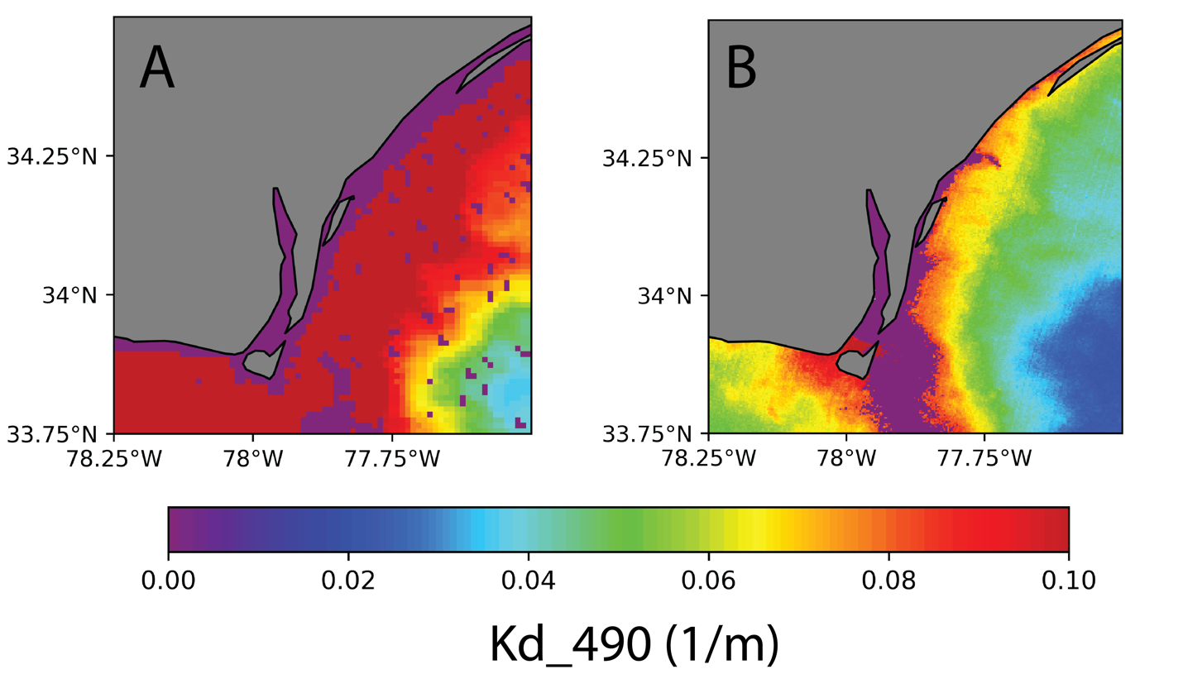

Figure 6: Kd_490 measurements of study area on May 7: A) MODIS-Aqua, B) HawkEye.

Kd490 is satellite parameter used to measure diffuse attenuation at 490 nm. Both the HawkEye and MODIS-Aqua indicate a Kd490 range of 0.06-0.10 1/m in our study area (Figure 6). The inverse of Kd, 1/Kd, is generally considered the first optical depth (roughly corresponding to the 37% light level) (NOAA, K490). This translates to a first optical depth measurement of 10-12.5 m. Our in-situ measurements are conducted at depths of 10 m or shallower. The total water depth in the study region is approximately 10-15 m. Given this, the depicted Chl concentrations display vertical inhomogeneity and are believed to be within the first optical depth of the coastal euphotic zone. However, it’s important to acknowledge that one optical depth may not be sufficient to prevent contaminations of R­rs by benthic reflectance. If a significant portion of light reaches the bottom of the 10-15 m depth and encounters a highly reflective surface like sand, it could potentially skew the measurements. In Figure 8, as well as in other figures containing MODIS imagery, the irregular 'dots' or speckling present in the data visualizations is an artifact from the data processing and mapping procedure and is not indicative of the sensor's output. Such artifacts arise during spatial processing of satellite imagery and do not influence the measured Kd_490 values, or other water column parameters.

Preliminary analysis of satellite-derived Chl concentrations in Onslow Bay revealed consistent spatio-temporal patterns across multiple satellite sensors. Specifically, all data sets pointed to a pronounced north-eastern region of elevated Chl levels contained within the Pamlico Sound. The HawkEye data from May 7, in particular, showed less intense concentrations near offshore Wrightsville Beach, differing from observations from Modis-Aqua and OCLI-S3A for the same timeframe.

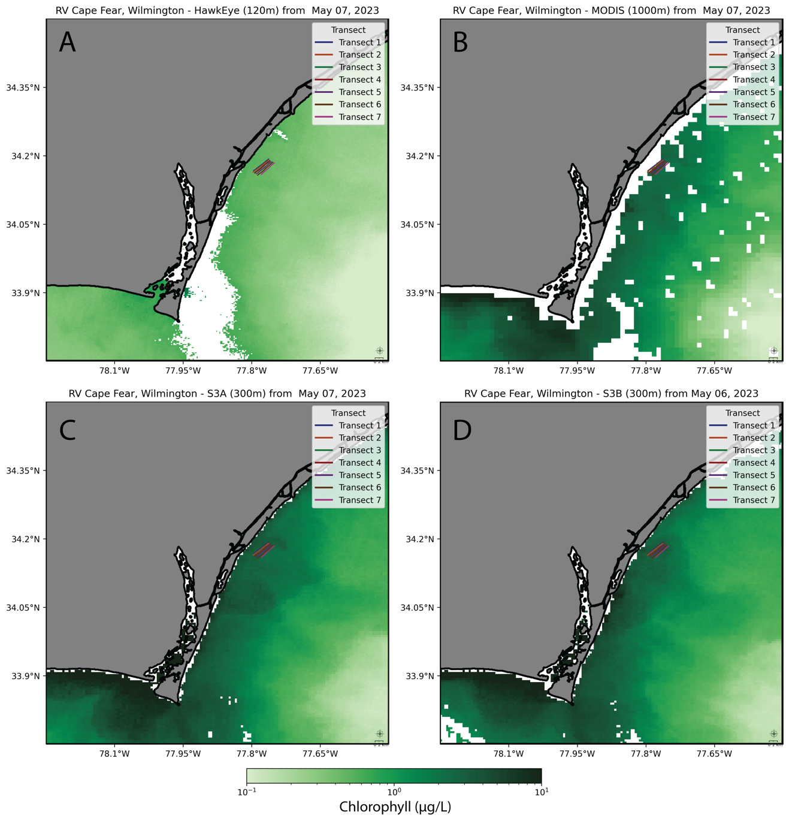

Figure 7: Satellite images of Cape Fear River Estuary and Wilmington region chlorophyll a concentration: A) HawkEye-SeaHawk, B) Modis-Aqua, C) OLCI-S3A, D) OLCI-S3B.

Detailed satellite images highlighted distinct Chl concentration gradients in both the CFRE and the offshore region of Wrightsville Beach. High concentrations are evident in the estuarine region and its immediate offshore vicinity, decreasing further offshore, which possibly suggests reduced nutrient input. Intense Chl pockets are noticeable near the river mouth as well. The superior spatial resolution of HawkEye becomes especially noticeable at this scale, offering a refined depiction of Chl distribution (Figure 7, Figure 8). While the different sensors provide varied spatial resolution details, they consistently illustrate a theme of higher Chl concentrations nearshore than offshore.

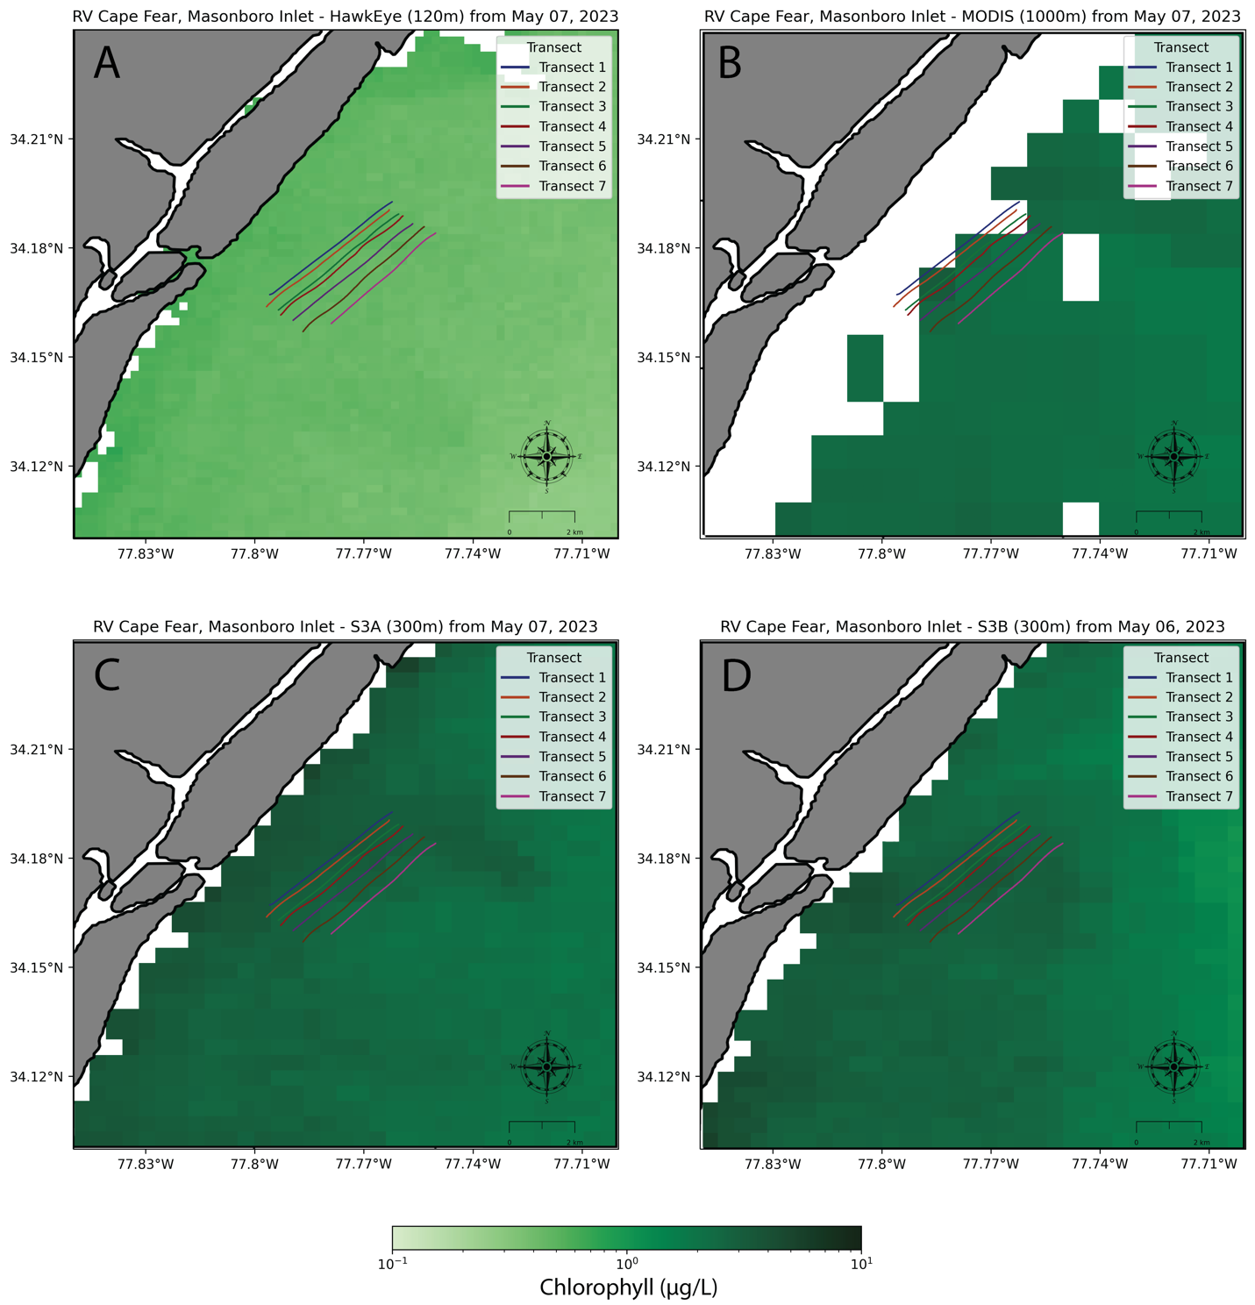

Figure 8: Seven transects of in-situ measurements taken at Masonboro Inlet overlaid onto satellite image matchups displaying chlorophyll concentration (g/L). A) HawkEye-SeaHawk, B) MODIS-Aqua, C) OLCI-S3A, D) OLCI-S3B.

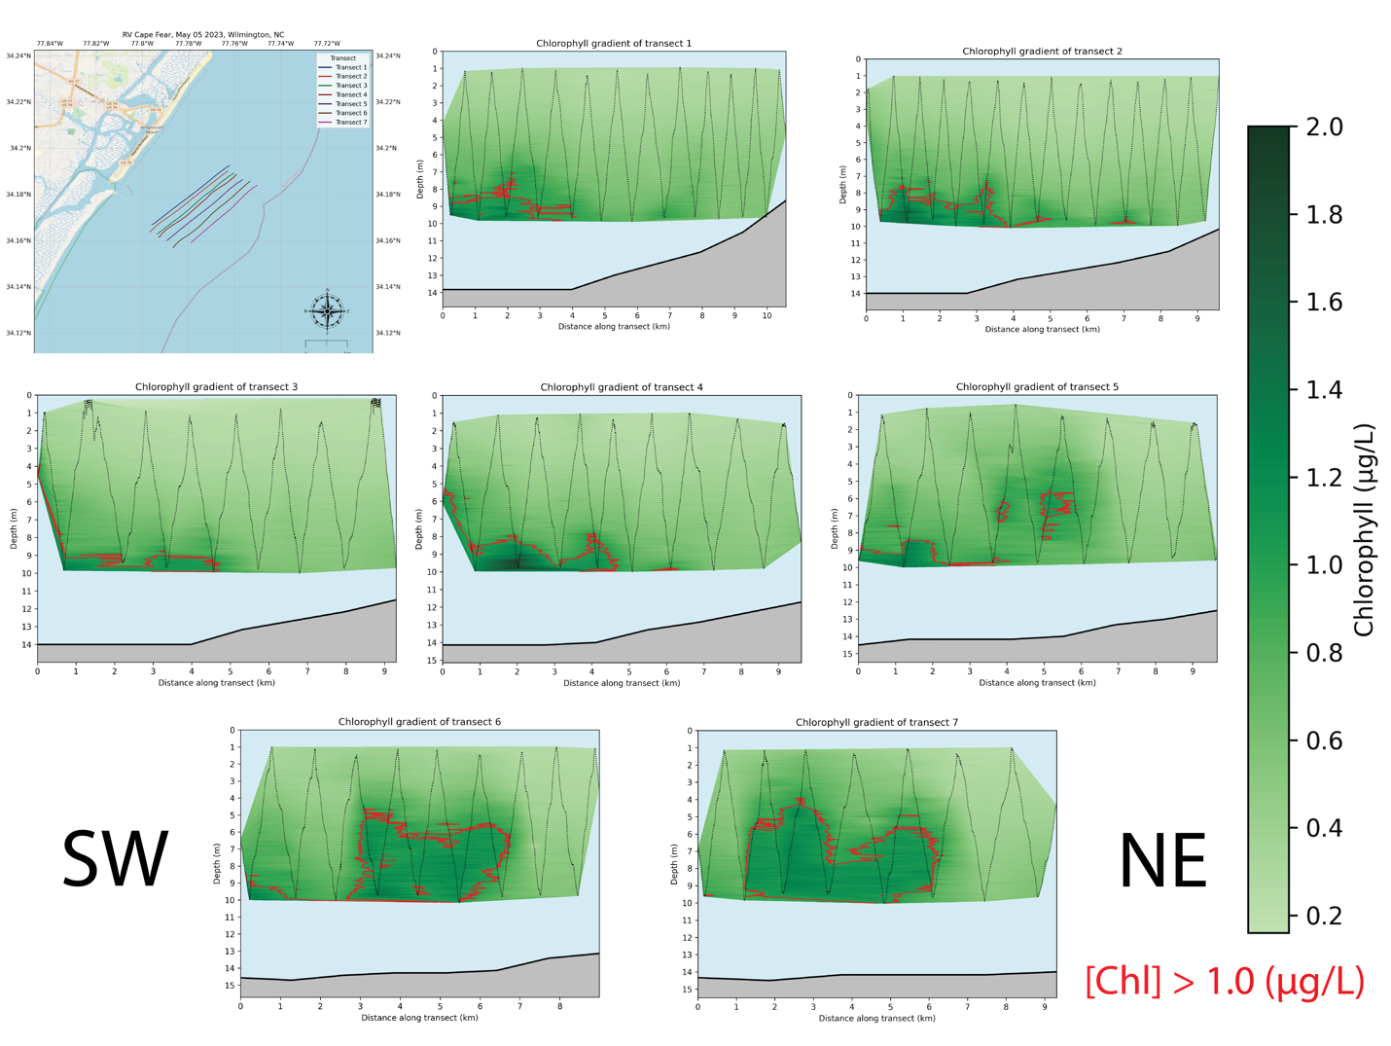

Figure 9: Transects with linearly interpolated Chl concentrations and the path of the Acrobat sampling device with bathymetry data added for reference. Chl plumes are considered measurements greater that 1.0 µg/L and are outlined in red.



Figure : Chl concentration (µg/L) at Masonboro Inlet interpolated linearly and plotted together by depth (m), distance from shore (km), and distance along transect (km).

Linear interpolation of Chl concentrations across the transects at Masonboro Inlet (Figure 9) each displayed unique Chl distribution patterns. Incorporating bathymetric data bathymetry data enhances our understanding of the relationship between Chl concentrations seafloor topography. This data can highlight areas influenced by water column mixing processes and aid in determining the depth of the euphotic zone. The subsurface layer consistently has the highest Chl concentrations, resembling a plume, hinting at a stratified water column, with slightly fresher water from the CFR with lower Chl content overlaying the saltier, Chl-rich coastal oceanic water. These layers might be affected by physical hydrodynamic processes and local environmental factors as well. Satellite sensors, however, might differ amongst each other in their Chl concentration estimations, based on which portions of the vertically inhomogeneous water column their pixels encompass. The 3D representation (Figure 10) provides a comprehensive view of the Chl distributions across the transects. This reveals areas of spatial continuity and discontinuity between adjacent transects and highlights the areas of concentration shifts and uniformity. Analyzing adjacent transects offers a detailed perspective on the bulk Chl distribution in the study region, mirroring what’s captured in remotely sensed data pixels. Collectively, these three figures offer different perspectives on Chl, and, similarly, turbidity (Figure 12, Figure 13) distributions in the water column, and provide a more comprehensive understanding of their spatial variability and patterns. The remotely sensed measurements will estimate these concentrations using a weighted average of the water column which will be compared with varying depths of in situ averages to evaluate sensor sensitivity.

­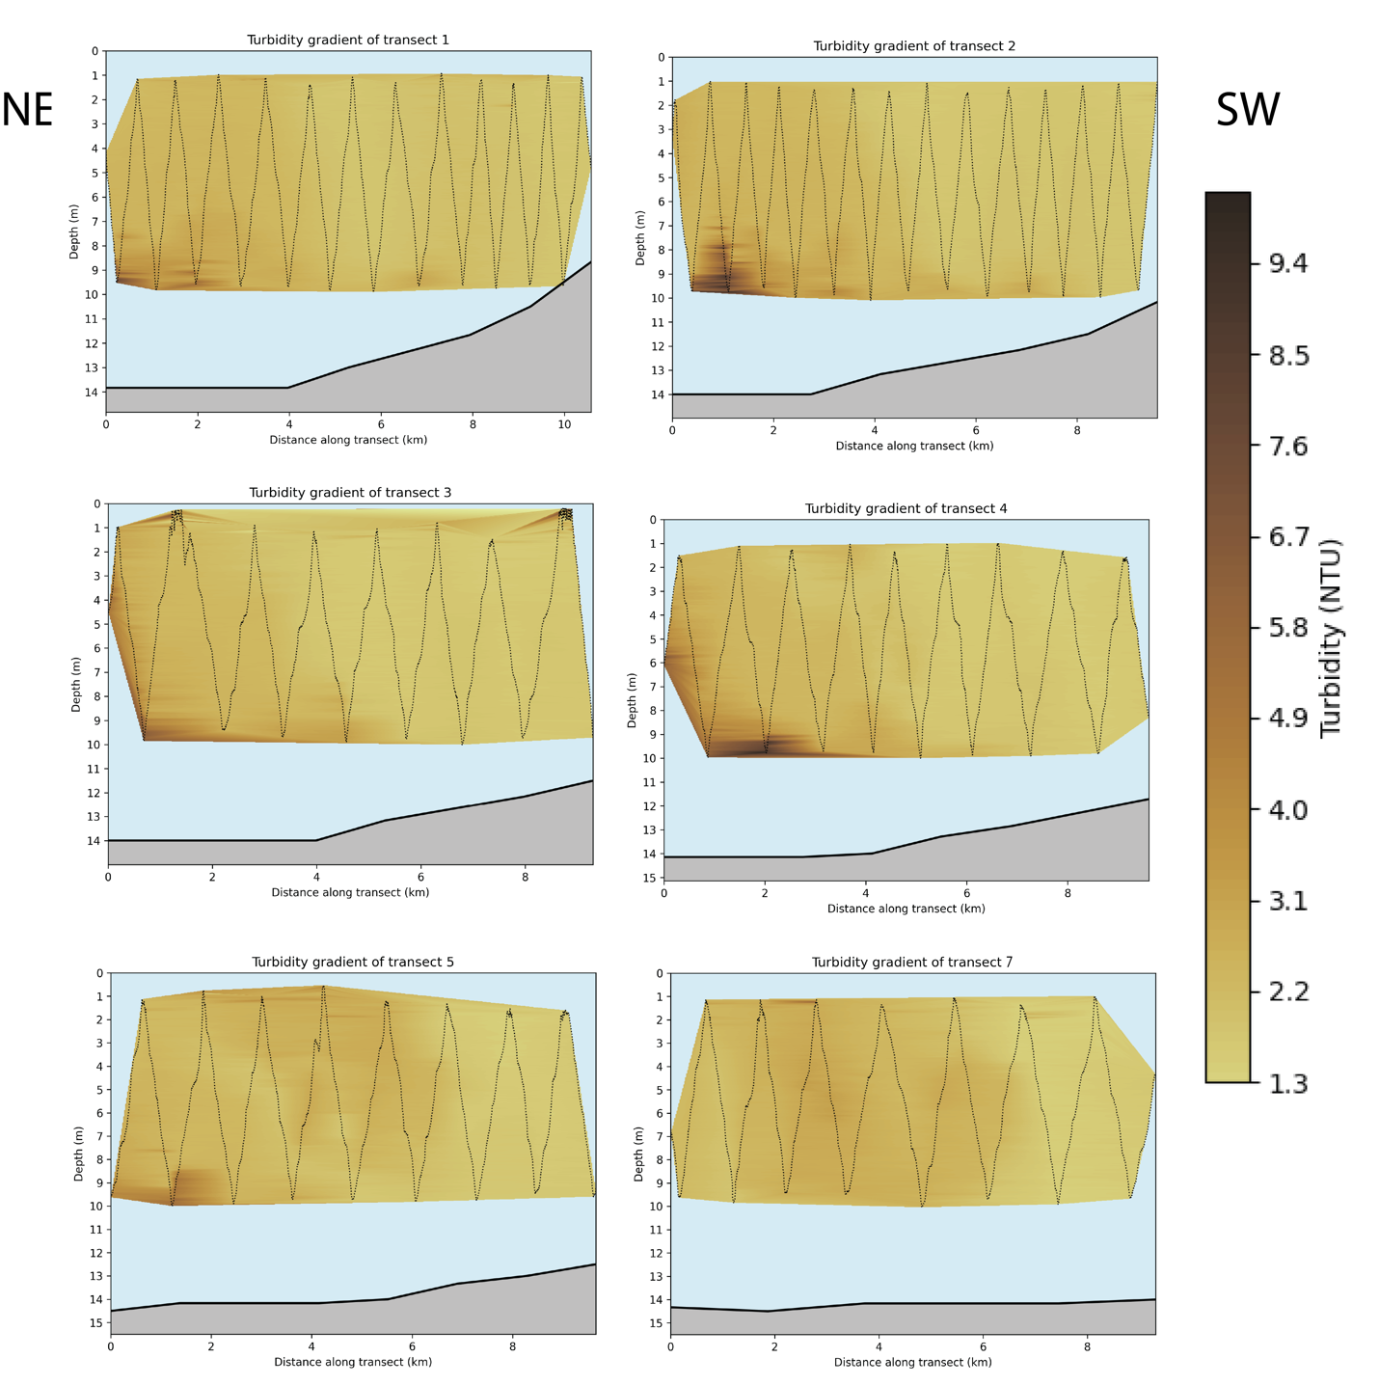

Figure : Interpolated turbidity concentration (NTU) along each transect with the Acrobat path at the mouth of Masonboro Inlet with bathymetry data added for reference.

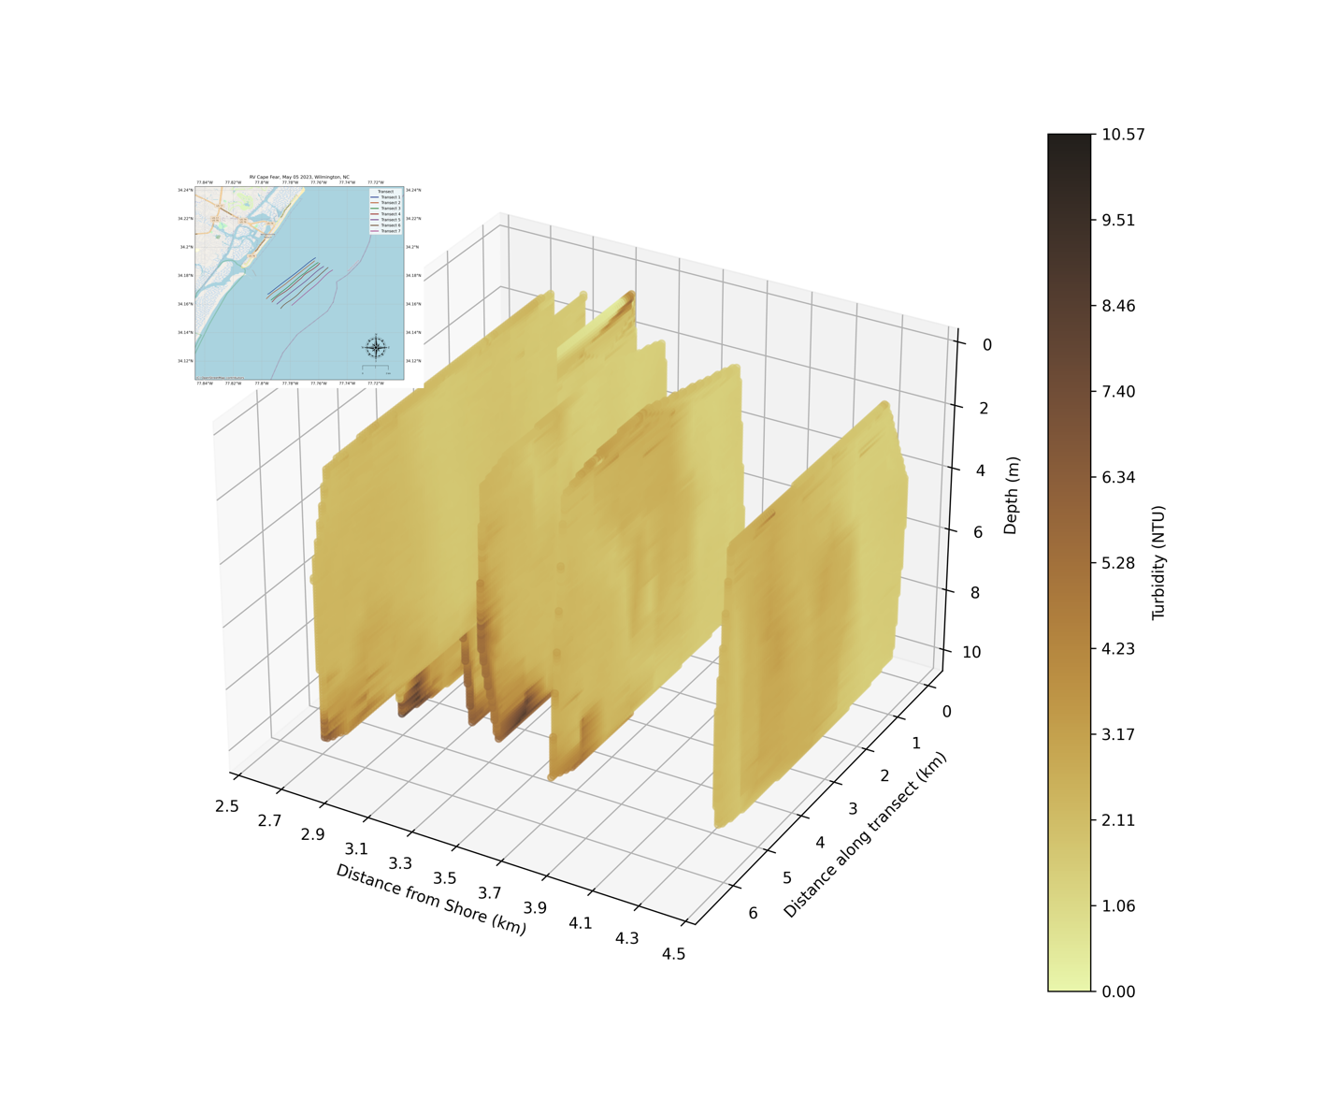

Figure : Six transects stacked side-by-side. Data from transect #6 is omitted due to erroneous data.

The provided salinity gradient plot along transect 1 of the CFR (Figure 14) illustrates the distribution of salinity as the vessel moved North up the river. Evidently, there’s pronounced vertical stratification, where surface layers (down to approximately 2-3 m in depth), show lower salinity levels, depicted by the deeper blue hues. This salinity increase with increasing depth, transitioning to the green and yellow tones, indicating saltwater influence. Horizontally, as on progresses from the left (0 km) to the right (5.5 km) of the transect, around the 2 to 3 km mark, the depth at which the salinity transition occurs is deeper than in surround areas, potentially highlighting a zone of enhanced water column mixing. The high-level trend of the salinity gradient displays quite clearly the salt wedge of the CFR.

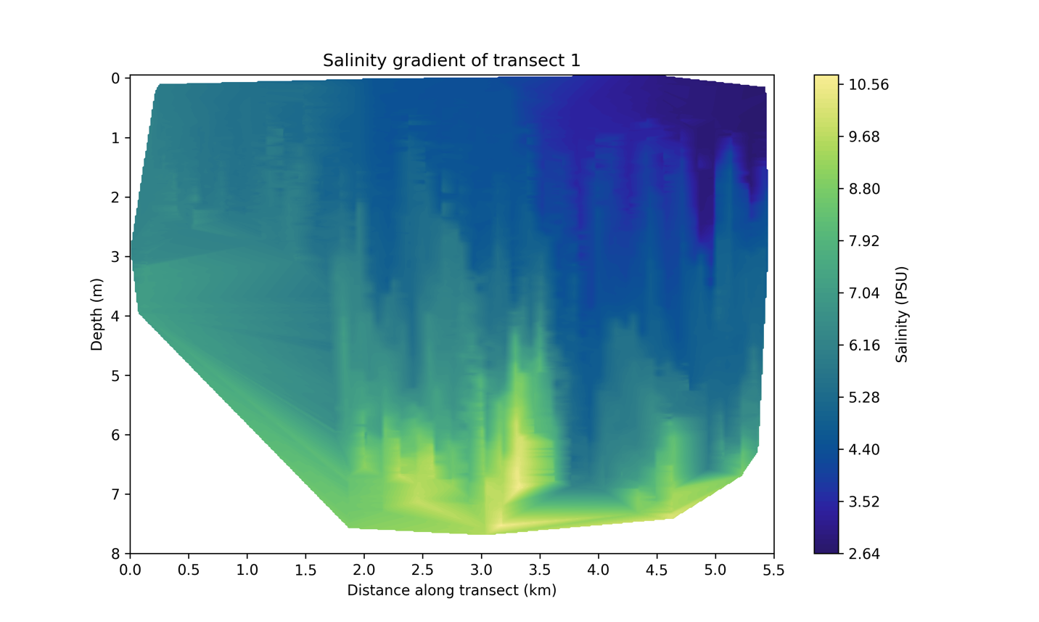

N

S

Figure : Interpolated salinity concentration along the transect in the Cape Fear River.

# Academic Plan

For my research thesis, I intend to work on the following future tasks:

* Process and analyze handheld spectroradiometer data and obtain Rrs at locations along the transects for both R/V Cape Fear research outings.
* Spatially bin satellite imagery to 3 x 3 pixel matrixes along the transects.
* Average the depth data of in situ chlorophyll within the first 10 m of the water column for comparison with satellite observed data.
* Pair satellite-derived data bins with their corresponding in situ observation averages based on latitude and longitude coordinates, centering the in-situ data in the bins.
* Conduct a statistical analysis to assess the consistency and accuracy of the satellite-derived data against in situ measurements. Quantify the discrepancies.
* Test varying depths for in-situ chlorophyll averages. Calculate sensitivity of agreement between satellite and in-situ data to chosen depth.
* Synthesize all findings, comparisons, and analyses in a comprehensive document and clearly articulate the details of the observations, methods, and results.
* Write and defend the thesis.

As for my academic plan, I have taken all required coursework and hours after this semester, so I will do continuous enrollment for the remainder of my time at UNCW. My timeline with some of the major tasks is as follows*:

|  |  |  |  |  |  |
| --- | --- | --- | --- | --- | --- |
| Task | Sept-Oct 2023 | Nov – Dec 2023 | Jan – Feb 2024 | Mar – Apr 2024 | May – July 2024 |
| Write and Defend Oral Prospectus |  |  |  |  |  |
| Data Preparation |  |  |  |  |  |
| Match-up Analysis |  |  |  |  |  |
| Statistical Evaluation |  |  |  |  |  |
| Write and defend the thesis |  |  |  |  |  |

* If graduating by July 2024 for a total of 24 months in the program

# References

Advocacy. Cape Fear River Watch. (N.D.-A). Https://Capefearriverwatch.Org/Cafos/

Allison, D. B., Stramski, D., & Mitchell, B. G. (2010). Seasonal And Interannual Variability Of Particulate Organic Carbon Within The Southern Ocean From Satellite Ocean Color Observations. Journal Of Geophysical Research, 115(C6). Https://Doi.Org/10.1029/2009jc005347

Baban, S. M. J. (1997). Environmental Monitoring Of Estuaries; Estimating And Mapping Various Environmental Indicators In Breydon Water Estuary, U.K., Using Landsat Tm Imagery. Estuarine, Coastal And Shelf Science, 44(5), 589–598. Https://Doi.Org/10.1006/Ecss.1996.0142

Baith, K., Lindsay, R., Fu, G., & McClain, C. R. (2001). Data Analysis System Developed For Ocean Color Satellite Sensors. Eos, Transactions American Geophysical Union, 82(18), 202–202. Https://Doi.Org/10.1029/01eo00109

Barbier, E. B. (2014). The Protective Value Of Estuarine And Coastal Ecosystems. Handbook On The Economics Of Ecosystem Services And Biodiversity. [Https://Doi.Org/10.4337/9781781951514.00008](https://doi.org/10.4337/9781781951514.00008)

Bauer, J. E., & Druffel, E. R. (1998). Ocean Margins As A Significant Source Of Organic Matter To The Deep Open Ocean. Nature, 392(6675), 482–485. Https://Doi.Org/10.1038/33122

Beck, M. W., Heck, K. L., Able, K. W., Childers, D. L., Eggleston, D. B., Gillanders, B. M., Halpern, B., Hays, C. G., Hoshino, K., Minello, T. J., Orth, R. J., Sheridan, P. F., & Weinstein, M. P. (2001). The Identification, Conservation, And Management Of Estuarine And Marine Nurseries For Fish And Invertebrates. Bioscience, 51(8), 633. [Https://Doi.Org/10.1641/0006-3568(2001)051[0633:Ticamo]2.0.Co;2](https://doi.org/10.1641/0006-3568(2001)051%5b0633:ticamo%5d2.0.co;2)

Behrenfeld, M. J., & Falkowski, P. G. (1997). Photosynthetic Rates Derived From Satellite-Based Chlorophyll Concentration. Limnology And Oceanography, 42(1), 1–20. Https://Doi.Org/10.4319/Lo.1997.42.1.0001

Belkin, I. M. (2021). Remote Sensing Of Ocean Fronts In Marine Ecology And Fisheries. Remote Sensing, 13(5), 883. Https://Doi.Org/10.3390/Rs13050883

Cao, H.-S., Kong, F.-X., Luo, L.-C., Shi, X.-L., Yang, Z., Zhang, X.-F., & Tao, Y. (2006). Effects Of Wind And Wind-Induced Waves On Vertical Phytoplankton Distribution And Surface Blooms Of Microcystis Aeruginosa In Lake Taihu. Journal Of Freshwater Ecology, 21(2), 231–238. Https://Doi.Org/10.1080/02705060.2006.9664991

Carr, M.-E., Friedrichs, M. A. M., Schmeltz, M., Noguchi Aita, M., Antoine, D., Arrigo, K. R., Asanuma, I., Aumont, O., Barber, R., Behrenfeld, M., Bidigare, R., Buitenhuis, E. T., Campbell, J., Ciotti, A., Dierssen, H., Dowell, M., Dunne, J., Esaias, W., Gentili, B., … Yamanaka, Y. (2006). A Comparison Of Global Estimates Of Marine Primary Production From Ocean Color. Deep Sea Research Part Ii: Topical Studies In Oceanography, 53(5–7), 741–770. [Https://Doi.Org/10.1016/J.Dsr2.2006.01.028](https://doi.org/10.1016/j.dsr2.2006.01.028)

Chen, S., Meng, Y., Lin, S., & Xi, J. (2022). Remote Sensing Of The Seasonal And Interannual Variability Of Surface Chlorophyll-A Concentration In The Northwest Pacific Over The Past 23 Years (1997–2020). Remote Sensing, 14(21), 5611. Https://Doi.Org/10.3390/Rs14215611

Clarke Gl, Ewing Gc, Lorenzen Cj. Spectra Of Backscattered Light From The Sea Obtained From Aircraft As A Measure Of Chlorophyll Concentration. Science. 1970 Feb 20;167(3921):1119-21. Doi: 10.1126/Science.167.3921.1119. Pmid: 17829405.

Delgado, A., Loisel, H., Jamet, C., Vantrepotte, V., Perillo, G., & Piccolo, M. (2015). Seasonal And Inter-Annual Analysis Of Chlorophyll-A And Inherent Optical Properties From Satellite Observations In The Inner And Mid-Shelves Of The South Of Buenos Aires Province (Argentina). Remote Sensing, 7(9), 11821–11847. [Https://Doi.Org/10.3390/Rs70911821](https://doi.org/10.3390/rs70911821)

Deng, L., Zhou, W., Cao, W., Wang, G., Zheng, W., Xu, Z., Li, C., Yang, Y., Xu, W., Zeng, K., & Hu, S. (2020). Evaluating Semi-Analytical Algorithms For Estimating Inherent Optical Properties In The South China Sea. Optics Express, 28(9), 13155. Https://Doi.Org/10.1364/Oe.390859

Dierssen, H. M. (2010). Perspectives On Empirical Approaches For Ocean Color Remote Sensing Of Chlorophyll In A Changing Climate. Proceedings Of The National Academy Of Sciences, 107(40), 17073–17078. Https://Doi.Org/10.1073/Pnas.0913800107

Dierssen, H. M., & Randolph, K. (2012). Remote Sensing Of Ocean Color. Encyclopedia Of Sustainability Science And Technology, 8952–8975. Https://Doi.Org/10.1007/Springerreference_310809

Doerffer, R., & Schiller, H. (2007). The Meris Case 2 Water Algorithm. International Journal Of Remote Sensing, 28(3–4), 517–535. [Https://Doi.Org/10.1080/01431160600821127](https://doi.org/10.1080/01431160600821127)

Doody, J. P. (2013). Sand Dune Conservation, Management And Restoration. Coastal Research Library. Https://Doi.Org/10.1007/978-94-007-4731-9

Dowell, M. (2012). Ocean Colour Algorithms. Ioccg Training.

Doxaran, D., Froidefond, J.-M., Castaing, P., & Babin, M. (2009). Dynamics Of The Turbidity Maximum Zone In A Macrotidal Estuary (The Gironde, France): Observations From Field And Modis Satellite Data. Estuarine, Coastal And Shelf Science, 81(3), 321–332. Https://Doi.Org/10.1016/J.Ecss.2008.11.013

Fan, Y., Li, W., Chen, N., Ahn, J.-H., Park, Y.-J., Kratzer, S., Schroeder, T., Ishizaka, J., Chang, R., & Stamnes, K. (2021). Oc-Smart: A Machine Learning Based Data Analysis Platform For Satellite Ocean Color Sensors. Remote Sensing Of Environment, 253, 112236. Https://Doi.Org/10.1016/J.Rse.2020.112236

Field, C. B., Behrenfeld, M. J., Randerson, J. T., & Falkowski, P. (1998). Primary Production Of The Biosphere: Integrating Terrestrial And Oceanic Components. Science, 281(5374), 237–240. Https://Doi.Org/10.1126/Science.281.5374.237

Fonseca, M. S., & Cahalan, J. A. (1992). A Preliminary Evaluation Of Wave Attenuation By Four Species Of Seagrass. Estuarine, Coastal And Shelf Science, 35(6), 565–576. [Https://Doi.Org/10.1016/S0272-7714(05)80039-3](https://doi.org/10.1016/s0272-7714(05)80039-3)

Franz, B. (2014, May). Nasa Ocean Biology Processing Group Update (Modis, Viirs, Meris, Hico, Goci, Sgli, Olci, Landsat-8, Multi-Mission Processing). Nasa Ocean Color Research Team. Washington D.C.

Franz, B. A. (2008). Moderate Resolution Imaging Spectroradiometer On Terra: Limitations For Ocean Color Applications. Journal Of Applied Remote Sensing, 2(1), 023525. Https://Doi.Org/10.1117/1.2957964

Franz, B. A., Bailey, S. W., Kuring, N., & Werdell, P. J. (2015). Ocean Color Measurements With The Operational Land Imager On Landsat-8: Implementation And Evaluation In Seadas. Journal Of Applied Remote Sensing, 9(1), 096070. Https://Doi.Org/10.1117/1.Jrs.9.096070

Franz, Bryan & Bailey, Sean & Meister, Gerhard & Werdell, Jeremy. (2012). Quality And Consistency Of The Nasa Ocean Color Data Record. 10.13140/2.1.2960.4169.

Ghermandi, A., Nunes, P. A. L. D., Portela, R., Rao, N., & Teelucksingh, S. S. (2011). Recreational, Cultural, And Aesthetic Services From Estuarine And Coastal Ecosystems. Treatise On Estuarine And Coastal Science, 217–237. [Https://Doi.Org/10.1016/B978-0-12-374711-2.01212-2](https://doi.org/10.1016/b978-0-12-374711-2.01212-2)

Gordon, H. R. (1997). Atmospheric Correction Of Ocean Color Imagery In The Earth Observing System Era. Journal Of Geophysical Research: Atmospheres, 102(D14), 17081–17106. Https://Doi.Org/10.1029/96jd02443

Gordon, H. R., & Wang, M. (1994). Retrieval Of Water-Leaving Radiance And Aerosol Optical Thickness Over The Oceans With Seawifs: A Preliminary Algorithm. Applied Optics, 33(3), 443. Https://Doi.Org/10.1364/Ao.33.000443

Gordon, H. R., Brown, O. B., Evans, R. H., Brown, J. W., Smith, R. C., Baker, K. S., & Clark, D. K. (1988). A Semianalytic Radiance Model Of Ocean Color. Journal Of Geophysical Research: Atmospheres, 93(D9), 10909–10924. Https://Doi.Org/10.1029/Jd093id09p10909

Gordon, H. R., Clark, D. K., Brown, J. W., Brown, O. B., Evans, R. H., & Broenkow, W. W. (1983). Phytoplankton Pigment Concentrations In The Middle Atlantic Bight: Comparison Of Ship Determinations And Czcs Estimates. Applied Optics, 22(1), 20. [Https://Doi.Org/10.1364/Ao.22.000020](https://doi.org/10.1364/ao.22.000020)

Häder, D.-P., & Gao, K. (2015). Interactions Of Anthropogenic Stress Factors On Marine Phytoplankton. Frontiers In Environmental Science, 3. Https://Doi.Org/10.3389/Fenvs.2015.00014

Han, L., & Jordan, K. J. (2005). Estimating And Mapping Chlorophyll‐A Concentration In Pensacola Bay, Florida Using Landsat Etm+ Data. International Journal Of Remote Sensing, 26(23), 5245–5254. Https://Doi.Org/10.1080/01431160500219182

He, Q., & Silliman, B. R. (2019). Climate Change, Human Impacts, And Coastal Ecosystems In The Anthropocene. Current Biology, 29(19). Https://Doi.Org/10.1016/J.Cub.2019.08.042

Hedges, J. I. (1992). Global Biogeochemical Cycles: Progress And Problems. Marine Chemistry, 39(1–3), 67–93. Https://Doi.Org/10.1016/0304-4203(92)90096-S

Hedges, J.I., Keil, R. G., & Benner, R. (1997). What Happens To Terrestrial Organic Matter In The Ocean? Organic Geochemistry, 27(5–6), 195–212. Https://Doi.Org/10.1016/S0146-6380(97)00066-1

Hedley, J., Roelfsema, C., Chollett, I., Harborne, A., Heron, S., Weeks, S., Skirving, W., Strong, A., Eakin, C., Christensen, T., Ticzon, V., Bejarano, S., & Mumby, P. (2016). Remote Sensing Of Coral Reefs For Monitoring And Management: A Review. Remote Sensing, 8(2), 118. Https://Doi.Org/10.3390/Rs8020118

Hemminga, M. A., & Nieuwenhuize, J. (1990). Seagrass Wrack-Induced Dune Formation On A Tropical Coast (Banc D’arguin, Mauritania). Estuarine, Coastal And Shelf Science, 31(4), 499–502. [Https://Doi.Org/10.1016/0272-7714(90)90040-X](https://doi.org/10.1016/0272-7714(90)90040-x)

Hill, V., & Cota, G. (2005). Spatial Patterns Of Primary Production On The Shelf, Slope And Basin Of The Western Arctic In 2002. Deep Sea Research Part Ii: Topical Studies In Oceanography, 52(24–26), 3344–3354. Https://Doi.Org/10.1016/J.Dsr2.2005.10.001

Hoegh-Guldberg, O. Et Al. 2015. Reviving The Ocean Economy: The Case For Action - 2015. Wwf International, Gland, Switzerland., Geneva, 60 Pp.

Hoegh-Guldberg, O., Poloczanska, E. S., Skirving, W., & Dove, S. (2017). Coral Reef Ecosystems Under Climate Change And Ocean Acidification. Frontiers In Marine Science, 4. [Https://Doi.Org/10.3389/Fmars.2017.00158](https://doi.org/10.3389/fmars.2017.00158)

Holmes, A., Feldman, G., Morrison, J., Patt, F., & Lee, S. (2018). Hawkeye Ocean Color Instrument: Performance Summary. Cubesats And Nanosats For Remote Sensing Ii. Https://Doi.Org/10.1117/12.2320654

Hu, C., Lee, Z., & Franz, B. (2012). Chlorophyll A Algorithms For Oligotrophic Oceans: A Novel Approach Based On Three-Band Reflectance Difference. Journal Of Geophysical Research: Oceans, 117(C1). [Https://Doi.Org/10.1029/2011jc007395](https://doi.org/10.1029/2011jc007395)

Ioccg (2000) Remote Sensing Of Ocean Colour In Coastal, And Other Optically-Complex,Waters, (Ed. S. Sathyendranath). Dartmouth, Ns, Canada, International Ocean-Colour Coordinating Group (Ioccg), 140pp. (Reports Of The International Ocean-Colour Coordinating Group, No. 3) Doi: Http://Dx.Doi.Org/10.25607/Obp-95

Ioccg (2006) Remote Sensing Of Inherent Optical Properties: Fundamentals, Tests Of Algorithms, And Applications, (Ed. Z-P. Lee). Dartmouth, Ns, Canada, International Ocean-Colour Coordinating Group (Ioccg), 126pp. (Reports Of The International Ocean-Colour Coordinating Group, No. 5). Doi: [Http://Dx.Doi.Org/10.25607/Obp-96](http://dx.doi.org/10.25607/OBP-96)

Ioccg (2008). Why Ocean Colour? The Societal Benefits Of Ocean-Colour Technology. Platt, T., Hoepffner, N., Stuart, V. And Brown, C. (Eds.), Reports Of The International Ocean-Colour Coordinating Group, No. 7, Ioccg, Dartmouth, Canada

Ioccg (2010) Atmospheric Correction For Remotely-Sensed Ocean-Colour Products.(Ed. Wang, M.). Dartmouth, Ns, Canada, International Ocean-Colour Coordinating Group (Ioccg), 78pp. (Reports Of The International Ocean-Colour Coordinating Group, No. 10). Doi: [Http://Dx.Doi.Org/10.25607/Obp-101](http://dx.doi.org/10.25607/OBP-101)

Jarrett, J.T., 1977. Sediment Budget Analysis, Wrightsville Beach To Kure Beach, North Carolina. Proc. Coastal Sediments ‘77. Asce, New York, Pp. 986-1005.

Jeffrey, H., Gorter, H., Gow, A., Clark, C., Holmes, A., Herrin, C., Sasaki, L., & Morrison, J. (2018). Seahawk: A Nanosatellite Mission For Sustained Ocean Observation. Proceedings Of The 13th Reinventing Space Conference, 83–93. [Https://Doi.Org/10.1007/978-3-319-32817-1_9](https://doi.org/10.1007/978-3-319-32817-1_9)

Kachelriess, D., Wegmann, M., Gollock, M., & Pettorelli, N. (2014). The Application Of Remote Sensing For Marine Protected Area Management. Ecological Indicators, 36, 169–177. Https://Doi.Org/10.1016/J.Ecolind.2013.07.003

Kathiresan, K., & Bingham, B. L. (2001). Biology Of Mangroves And Mangrove Ecosystems. Advances In Marine Biology, 81–251. Https://Doi.Org/10.1016/S0065-2881(01)40003-4

Kwiatkowska, E. J., Franz, B. A., Meister, G., McClain, C. R., & Xiong, X. (2008). Cross Calibration Of Ocean-Color Bands From Moderate Resolution Imaging Spectroradiometer On Terra Platform. Applied Optics, 47(36), 6796. Https://Doi.Org/10.1364/Ao.47.006796

Landsat 8. Landsat 8 | U.S. Geological Survey. (N.D.). Https://Www.Usgs.Gov/Landsat-Missions/Landsat-8

Lavender, S. J., Pinkerton, M. H., Moore, G. F., Aiken, J., & Blondeau-Patissier, D. (2005). Modification To The Atmospheric Correction Of Seawifs Ocean Colour Images Over Turbid Waters. Continental Shelf Research, 25(4), 539–555. [Https://Doi.Org/10.1016/J.Csr.2004.10.007](https://doi.org/10.1016/j.csr.2004.10.007)

Lee, Z., Carder, K. L., & Arnone, R. A. (2002). Deriving Inherent Optical Properties From Water Color: A Multiband Quasi-Analytical Algorithm For Optically Deep Waters. Applied Optics, 41(27), 5755. Https://Doi.Org/10.1364/Ao.41.005755

Lee, Z., Jiang, M., Davis, C., Pahlevan, N., Ahn, Y.-H., & Ma, R. (2012). Impact Of Multiple Satellite Ocean Color Samplings In A Day On Assessing Phytoplankton Dynamics. Ocean Science Journal, 47(3), 323–329. Https://Doi.Org/10.1007/S12601-012-0031-5

Loisel, H., Vantrepotte, V., Jamet, C., & Ngoc Dat, D. (2013b). Challenges And New Advances In Ocean Color Remote Sensing Of Coastal Waters. Topics In Oceanography. Https://Doi.Org/10.5772/56414

Macreadie, P. I., Anton, A., Raven, J. A., Beaumont, N., Connolly, R. M., Friess, D. A., Kelleway, J. J., Kennedy, H., Kuwae, T., Lavery, P. S., Lovelock, C. E., Smale, D. A., Apostolaki, E. T., Atwood, T. B., Baldock, J., Bianchi, T. S., Chmura, G. L., Eyre, B. D., Fourqurean, J. W., … Duarte, C. M. (2019). The Future Of Blue Carbon Science. Nature Communications, 10(1). [Https://Doi.Org/10.1038/S41467-019-11693-W](https://doi.org/10.1038/s41467-019-11693-w)

Maritorena, S., Siegel, D. A., & Peterson, A. R. (2002). Optimization Of A Semianalytical Ocean Color Model For Global-Scale Applications. Applied Optics, 41(15), 2705. Https://Doi.Org/10.1364/Ao.41.002705

Masonboro Inlet. Capefear. (N.D.). Https://Www.Capefear-Nc.Com/Masonboro-Inlet.Html

Masson, S., B. Pinel-Alloul, And P. Dutilleul, 2004, Spatial Heterogeneity Of Zooplankton Biomass And Size Structure In Southern Québec Lakes: Variation Among Lakes And Within Lake Among Epi-, Meta- And Hypolimnion Strata, J. Plankton Res. 26:1441–1458.

McClain, C. R. (2009). A Decade Of Satellite Ocean Color Observations. Annual Review Of Marine Science, 1(1), 19–42. Https://Doi.Org/10.1146/Annurev.Marine.010908.163650

McClain, C. R., Pietrafesa, L. J., & Yoder, J. A. (1984). Observations Of Gulf Stream-Induced And Wind-Driven Upwelling In The Georgia Bight Using Ocean Color And Infrared Imagery. Journal Of Geophysical Research, 89(C3), 3705. Https://Doi.Org/10.1029/Jc089ic03p03705

McClain, C. R., Franz, B. A., & Werdell, P. J. (2022). Genesis And Evolution Of Nasa’s Satellite Ocean Color Program. Frontiers In Remote Sensing, 3. Https://Doi.Org/10.3389/Frsen.2022.938006

Mcleod, E., Chmura, G. L., Bouillon, S., Salm, R., Björk, M., Duarte, C. M., Lovelock, C. E., Schlesinger, W. H., & Silliman, B. R. (2011). A Blueprint For Blue Carbon: Toward An Improved Understanding Of The Role Of Vegetated Coastal Habitats In Sequestering Co2. Frontiers In Ecology And The Environment, 9(10), 552–560. [Https://Doi.Org/10.1890/110004](https://doi.org/10.1890/110004)

Mehner, T., F. Hölker, And P. Kasprzak, 2005, Spatial And Temporal Heterogeneity Of Trophic Variables In A Deep Lake As Reflected By Repeated Singular Sampling, Oikos 108:401–409.

Miller, R. L., & Mckee, B. A. (2004). Using Modis Terra 250 M Imagery To Map Concentrations Of Total Suspended Matter In Coastal Waters. Remote Sensing Of Environment, 93(1–2), 259–266. Https://Doi.Org/10.1016/J.Rse.2004.07.012

Mobley, C. (2020). Inherent Optical Properties. Ocean Optics Web Book. Https://Www.Oceanopticsbook.Info/View/Inherent-And-Apparent-Optical-Properties/Inherent-Optical-Properties

Mobley, C.D., Sundman, L.K., 2008. Hydrolight 5. Ecolight5 User Guide.

Modis diffuse attenuation coefficient at 490 nm (KD490). MODIS K490 - NOAA CoastWatch East Coast Node. (n.d.). https://eastcoast.coastwatch.noaa.gov/cw_k490.php

Morel, A. (2001). Bio-Optical Models. Encyclopedia Of Ocean Sciences, 317–326. Https://Doi.Org/10.1006/Rwos.2001.0407

Morrison, J. M., Jeffrey, H., Gorter, H., Anderson, P., Clark, C., Holmes, A., Feldman, G. C., & Patt, F. S. (2016). Seahawk: An Advanced Cubesat Mission For Sustained Ocean Colour Monitoring. Spie Proceedings. Https://Doi.Org/10.1117/12.2241058

Moses, W. J., Gitelson, A. A., Berdnikov, S., Saprygin, V., & Povazhnyi, V. (2012). Operational Meris-Based Nir-Red Algorithms For Estimating Chlorophyll-A Concentrations In Coastal Waters — The Azov Sea Case Study. Remote Sensing Of Environment, 121, 118–124. [Https://Doi.Org/10.1016/J.Rse.2012.01.024](https://doi.org/10.1016/j.rse.2012.01.024)

Mueller, J.L, Et Al., 2000. Above-Water Radiance And Remote Sensing Reflectance Measurements And Analysis Protocols, In: Fargion, G.S., Mueller, J.L. (Eds.), Ocean Optics Protocols For Satellite Ocean Color Sensor Validation. National Aeronautical And Space Administration, Washingotn, Usa.

Mutia, D., & Sailale, I. (2021). Application Of Remote Sensing And Gis To Identifying Marine Fisheries Off The Coasts Of Kenya And Tanzania. Oceanography, 46–47. Https://Doi.Org/10.5670/Oceanog.2021.Supplement.02-18

Nagelkerken, I. (2007). Are Non-Estuarine Mangroves Connected To Coral Reefs Through Fish Migration? Bulletin Of Marine Science, 80(3), 595–607.

Nagelkerken, I., Sheaves, M., Baker, R., & Connolly, R. M. (2013). The Seascape Nursery: A Novel Spatial Approach To Identify And Manage Nurseries For Coastal Marine Fauna. Fish And Fisheries, 16(2), 362–371. Https://Doi.Org/10.1111/Faf.12057

Nasa. (N.D.). Copernicus Sentinel-3 Ocean And Land Colour Instrument (Olci) - Laads Daac. Nasa. Https://Ladsweb.Modaps.Eosdis.Nasa.Gov/Missions-And-Measurements/Olci/

Nasa. (N.D.). Modis Web. Nasa. [Https://Modis.Gsfc.Nasa.Gov/About/Specifications.Php](https://modis.gsfc.nasa.gov/about/specifications.php)

Nasa. (N.D.). Nasa Ocean Color. Nasa. Https://Oceancolor.Gsfc.Nasa.Gov/Data/Reprocessing/R2014/

Nasa. (N.D.). Nasa Ocean Color. Nasa. Https://Oceancolor.Gsfc.Nasa.Gov/Data/Seawifs/Seastar/Spacecraft/

Nasa. (N.D.). Nasa Ocean Color. Nasa. Https://Oceancolor.Gsfc.Nasa.Gov/Data/Czcs/Instrument/

Nasa. (N.D.). Visible Infrared Imaging Radiometer Suite (Viirs) - Laads Daac. Nasa. [Https://Ladsweb.Modaps.Eosdis.Nasa.Gov/Missions-And-Measurements/Viirs](https://ladsweb.modaps.eosdis.nasa.gov/missions-and-measurements/viirs)

Nc. (N.D.). Https://Files.Nc.Gov/Deqee/Documents/Files/Cape-Fear-River-Basin.Pdf

Neill, W. E., 1994, Spatial And Temporal Scaling And The Organization Of Limnetic Communities, Chapter 7, In: Aquatic Ecology: Scale, Pattern And Process, P. S., A. Giller, G. Hildrew, And D. Rafaelli, Eds., Proceedings Of British Ecological Society And American Society Of Limnology And Oceanog

Ody, A., Doxaran, D., Vanhellemont, Q., Nechad, B., Novoa, S., Many, G., Bourrin, F., Verney, R., Pairaud, I., & Gentili, B. (2016). Potential Of High Spatial And Temporal Ocean Color Satellite Data To Study The Dynamics Of Suspended Particles In A Micro-Tidal River Plume. Remote Sensing, 8(3), 245. Https://Doi.Org/10.3390/Rs8030245

O’reilly, J. E., & Werdell, P. J. (2019). Chlorophyll Algorithms For Ocean Color Sensors - Oc4, Oc5 & Oc6. Remote Sensing Of Environment, 229, 32–47. Https://Doi.Org/10.1016/J.Rse.2019.04.021

O’reilly, J. E., Maritorena, S., Mitchell, B. G., Siegel, D. A., Carder, K. L., Garver, S. A., Kahru, M., & McClain, C. (1998). Ocean Color Chlorophyll Algorithms For Seawifs. Journal Of Geophysical Research: Oceans, 103(C11), 24937–24953. Https://Doi.Org/10.1029/98jc02160

O'reilly, J.E., Maritorena, S., O'brien, M., Siegel, D., Toole, D., Menzies, D., Smith, R., Mueller, J., Mitchell, G., Kahru, M., Chavez, F., Strutton, P., Cota, G., Hooker, S., McClain, C., Carder, K., Muller-Karger, F., Harding, L., Magnuson, A., Phinney, D., Moore, G., Aiken, J., Arrigo, K., Letelier, R., Culver, M., (2000). Ocean Color Chlorophyll A Algorithms For Seawifs, Oc2, And Oc4: Version 4. In: Hooker, S.B., Firestone, E.R. (Eds.), Seawifs Postlaunch Calibration And Validation Analyses, Part 3. Nasa Tech. Memo. 2000-206892 11. Nasa Goddard Space Flight Center, Greenbelt, Pp. 9–23.

Pilkey, O. H., & Tonya D. Clayton. (1989). Summary Of Beach Replenishment Experience On U.S. East Coast Barrier Islands. Journal Of Coastal Research, 5(1), 147–159. Http://Www.Jstor.Org/Stable/4297507

Pingree, R. D., Holligan, P. M., Mardell, G. T., And Head, R. N. 1976. The Influence Of Physical Stability On Spring, Summer And Autumn Phytoplankton Blooms In The Celtic Sea. Journal Of The Marine Biological Association Of The United Kingdom, 56: 845–873.

Prieur, L., & Sathyendranath, S. (1981). An Optical Classification Of Coastal And Oceanic Waters Based On The Specific Spectral Absorption Curves Of Phytoplankton Pigments, Dissolved Organic Matter, And Other Particulate Materials1. Limnology And Oceanography, 26(4), 671–689. Https://Doi.Org/10.4319/Lo.1981.26.4.0671

Rabalais, N. N., Turner, R. E., Justić, D., Dortch, Q., Wiseman, W. J., Gupta, B. K., & Justic, D. (1996). Nutrient Changes In The Mississippi River And System Responses On The Adjacent Continental Shelf. Estuaries, 19(2), 386. Https://Doi.Org/10.2307/1352458

Robert A. Barnes, Robert E. Eplee, G. Michael Schmidt, Frederick S. Patt, And Charles R. McClain, "Calibration Of Seawifs. I. Direct Techniques," Appl. Opt. 40, 6682-6700 (2001)

Ruddick, K. G., Ovidio, F., & Rijkeboer, M. (2000). Atmospheric Correction Of Seawifs Imagery For Turbid Coastal And Inland Waters. Applied Optics, 39(6), 897. Https://Doi.Org/10.1364/Ao.39.000897

Saba, V. S., Friedrichs, M. A., Antoine, D., Armstrong, R. A., Asanuma, I., Behrenfeld, M. J., Ciotti, A. M., Dowell, M., Hoepffner, N., Hyde, K. J., Ishizaka, J., Kameda, T., Marra, J., Mélin, F., Morel, A., O’reilly, J., Scardi, M., Smith, W. O., Smyth, T. J., … Westberry, T. K. (2011). An Evaluation Of Ocean Color Model Estimates Of Marine Primary Productivity In Coastal And Pelagic Regions Across The Globe. Biogeosciences, 8(2), 489–503. [Https://Doi.Org/10.5194/Bg-8-489-2011](https://doi.org/10.5194/bg-8-489-2011)

Sathyendranath, S., Cota, G., Stuart, V., Maass, H., & Platt, T. (2001). Remote Sensing Of Phytoplankton Pigments: A Comparison Of Empirical And Theoretical Approaches. International Journal Of Remote Sensing, 22(2–3), 249–273. Https://Doi.Org/10.1080/014311601449925

Sathyendranath, Shubha, Brewin, R., Brockmann, C., Brotas, V., Calton, B., Chuprin, A., Cipollini, P., Couto, A., Dingle, J., Doerffer, R., Donlon, C., Dowell, M., Farman, A., Grant, M., Groom, S., Horseman, A., Jackson, T., Krasemann, H., Lavender, S., … Platt, T. (2019). An Ocean-Colour Time Series For Use In Climate Studies: The Experience Of The Ocean-Colour Climate Change Initiative (Oc-Cci). Sensors, 19(19), 4285. Https://Doi.Org/10.3390/S19194285

Sathyendranath, S., Stuart, V., Irwin, B. D., Maass, H., Savidge, G., Gilpin, L., & Platt, T. (1999). Seasonal Variations In Bio-Optical Properties Of Phytoplankton In The Arabian Sea. Deep Sea Research Part Ii: Topical Studies In Oceanography, 46(3–4), 633–653. Https://Doi.Org/10.1016/S0967-0645(98)00121-0

Schlünz, B., & Schneider, R. R. (2000). Transport Of Terrestrial Organic Carbon To The Oceans By Rivers: Re-Estimating Flux- And Burial Rates. International Journal Of Earth Sciences, 88(4), 599–606. Https://Doi.Org/10.1007/S005310050290

Schofield, O., Arnone, R., Bissett, P., Dickey, T., Davis, C., Finkel, Z., Oliver, M., & Moline, M. (2004). Watercolors In The Coastal Zone: What Can We See? Oceanography, 17(2), 24–31. Https://Doi.Org/10.5670/Oceanog.2004.44

Seahawk-1 Cubesat Ocean Color Mission. Eoportal. (N.D.). Https://Www.Eoportal.Org/Satellite-Missions/Seahawk-1#Seahawk-1-Cubesat-Ocean-Color-Mission

Sentinel-2 - Missions - Sentinel Online. Sentinel Online. (N.D.-A). Https://Sentinels.Copernicus.Eu/Web/Sentinel/Missions/Sentinel-2

Seymour, J. R., J. G. Mitchell, And L. Seuront, 2004, Microscale Heterogeneity In The Activity Of Coastal Bacterioplankton Communities, Aquat. Microb. Ecol. 35:1–16.

Sheaves, M., Baker, R., Nagelkerken, I., & Connolly, R. M. (2014). True Value Of Estuarine And Coastal Nurseries For Fish: Incorporating Complexity And Dynamics. Estuaries And Coasts, 38(2), 401–414. [Https://Doi.Org/10.1007/S12237-014-9846-X](https://doi.org/10.1007/s12237-014-9846-x)

Shen, L., Xu, H., & Guo, X. (2012). Satellite Remote Sensing Of Harmful Algal Blooms (Habs) And A Potential Synthesized Framework. Sensors, 12(6), 7778–7803. Https://Doi.Org/10.3390/S120607778

Shi, K., Zhang, Y., Liu, X., Wang, M., & Qin, B. (2014). Remote Sensing Of Diffuse Attenuation Coefficient Of Photosynthetically Active Radiation In Lake Taihu Using Meris Data. Remote Sensing Of Environment, 140, 365–377. Https://Doi.Org/10.1016/J.Rse.2013.09.013

Siegel, D. A., Buesseler, K. O., Doney, S. C., Sailley, S. F., Behrenfeld, M. J., & Boyd, P. W. (2014). Global Assessment Of Ocean Carbon Export By Combining Satellite Observations And Food-Web Models. Global Biogeochemical Cycles, 28(3), 181–196. Https://Doi.Org/10.1002/2013gb004743

Siegel, David A., Wang, M., Maritorena, S., & Robinson, W. (2000). Atmospheric Correction Of Satellite Ocean Color Imagery: The Black Pixel Assumption. Applied Optics, 39(21), 3582. [Https://Doi.Org/10.1364/Ao.39.003582](https://doi.org/10.1364/ao.39.003582)

Silulwane, N. F., Richardson, A. J., Shillington, F. A., & Mitchell-Innes, B. A. (2001). Identification And Classification Of Vertical Chlorophyll Patterns In The Benguela Upwelling System And Angola-Benguela Front Using An Artificial Neural Network. South African Journal Of Marine Science, 23(1), 37–51. Https://Doi.Org/10.2989/025776101784528872

Smith, R. C., & Baker, K. S. (1978). Optical Classification Of Natural Waters 1. Limnology And Oceanography, 23(2), 260–267. Https://Doi.Org/10.4319/Lo.1978.23.2.0260

Stumpf, Richard & Arnone, Robert & Gould, R. & Martinolich, P. & Ransibrahmanakul, Varis. (2003). A Partially Coupled Ocean-Atmosphere Model For Retrieval Of Water-Leaving Radiance From Seawifs In Coastal Waters. Nasa Tech. Memo. 206892. 51-59.

Siegel, D. A., Doney, S. C., & Yoder, J. A. (2002). The North Atlantic Spring Phytoplankton Bloom And Sverdrup’s Critical Depth Hypothesis. Science, 296(5568), 730–733. Https://Doi.Org/10.1126/Science.1069174

Sverdrup, H. U. (1953). On Conditions For The Vernal Blooming Of Phytoplankton. Ices Journal Of Marine Science, 18(3), 287–295. Https://Doi.Org/10.1093/Icesjms/18.3.287

Tilstone, G. H., Lotliker, A. A., Miller, P. I., Ashraf, P. M., Kumar, T. S., Suresh, T., Ragavan, B. R., & Menon, H. B. (2013). Assessment Of Modis-Aqua Chlorophyll-A Algorithms In Coastal And Shelf Waters Of The Eastern Arabian Sea. Continental Shelf Research, 65, 14–26. Https://Doi.Org/10.1016/J.Csr.2013.06.003

Tran, T. K., Duforêt-Gaurier, L., Vantrepotte, V., Jorge, D. S., Mériaux, X., Cauvin, A., Fanton D’andon, O., & Loisel, H. (2019). Deriving Particulate Organic Carbon In Coastal Waters From Remote Sensing: Inter-Comparison Exercise And Development Of A Maximum Band-Ratio Approach. Remote Sensing, 11(23), 2849. Https://Doi.Org/10.3390/Rs11232849

User Guides - Sentinel-3 Olci - Sentinel Online. Sentinel Online. (N.D.). Https://Sentinels.Copernicus.Eu/Web/Sentinel/User-Guides/Sentinel-3-Olci

Valiela, I., Bowen, J. L., & York, J. K. (2001). Mangrove Forests: One Of The World’s Threatened Major Tropical Environments. Bioscience, 51(10), 807. [Https://Doi.Org/10.1641/0006-3568(2001)051[0807:Mfootw]2.0.Co;2](https://doi.org/10.1641/0006-3568(2001)051%5b0807:mfootw%5d2.0.co;2)

Vanhellemont, Q., & Ruddick, K. (2014). Turbid Wakes Associated With Offshore Wind Turbines Observed With Landsat 8. Remote Sensing Of Environment, 145, 105–115. Https://Doi.Org/10.1016/J.Rse.2014.01.009

Vanhellemont, Q., & Ruddick, K. (2015). Advantages Of High Quality Swir Bands For Ocean Colour Processing: Examples From Landsat-8. Remote Sensing Of Environment, 161, 89–106. [Https://Doi.Org/10.1016/J.Rse.2015.02.007](https://doi.org/10.1016/j.rse.2015.02.007)

Wagh, P., Sojan, J. M., Babu, S. J., Valsala, R., Bhatia, S., & Srivastav, R. (2020). Indicative Lake Water Quality Assessment Using Remote Sensing Images-Effect Of Covid-19 Lockdown. Water, 13(1), 73. Https://Doi.Org/10.3390/W13010073

Wang, J., Wang, Y., Lee, Z., Wang, D., Chen, S., & Lai, W. (2022). A Revision Of Nasa Seadas Atmospheric Correction Algorithm Over Turbid Waters With Artificial Neural Networks Estimated Remote-Sensing Reflectance In The Near-Infrared. Isprs Journal Of Photogrammetry And Remote Sensing, 194, 235–249. Https://Doi.Org/10.1016/J.Isprsjprs.2022.10.014

Wang, M., Shi, W., & Tang, J. (2011). Water Property Monitoring And Assessment For China’s Inland Lake Taihu From Modis-Aqua Measurements. Remote Sensing Of Environment, 115(3), 841–854. [Https://Doi.Org/10.1016/J.Rse.2010.11.012](https://doi.org/10.1016/j.rse.2010.11.012)

Wang, M., Son, S., & Shi, W. (2009). Evaluation Of Modis Swir And Nir-Swir Atmospheric Correction Algorithms Using Seabass Data. Remote Sensing Of Environment, 113(3), 635–644. Https://Doi.Org/10.1016/J.Rse.2008.11.005

Wang, M., Tang, J., & Shi, W. (2007). Modis-Derived Ocean Color Products Along The China East Coastal Region. Geophysical Research Letters, 34(6). [Https://Doi.Org/10.1029/2006gl028599](https://doi.org/10.1029/2006gl028599)

Wang, Y., Lee, Z., Wei, J., Shang, S., Wang, M., & Lai, W. (2021). Extending Satellite Ocean Color Remote Sensing To The Near-Blue Ultraviolet Bands. Remote Sensing Of Environment, 253, 112228. Https://Doi.Org/10.1016/J.Rse.2020.112228

Werdell, P. J., & Bailey, S. W. (2005). An Improved In-Situ Bio-Optical Data Set For Ocean Color Algorithm Development And Satellite Data Product Validation. Remote Sensing Of Environment, 98(1), 122–140. Https://Doi.Org/10.1016/J.Rse.2005.07.001

Werdell, P. J., Mckinna, L. I. W., Boss, E., Ackleson, S. G., Craig, S. E., Gregg, W. W., Lee, Z., Maritorena, S., Roesler, C. S., Rousseaux, C. S., Stramski, D., Sullivan, J. M., Twardowski, M. S., Tzortziou, M., & Zhang, X. (2018). An Overview Of Approaches And Challenges For Retrieving Marine Inherent Optical Properties From Ocean Color Remote Sensing. Progress In Oceanography, 160, 186–212. Https://Doi.Org/10.1016/J.Pocean.2018.01.001

Westberry, T. K., Schultz, P., Behrenfeld, M. J., Dunne, J. P., Hiscock, M. R., Maritorena, S., Sarmiento, J. L., & Siegel, D. A. (2016). Annual Cycles Of Phytoplankton Biomass In The Subarctic Atlantic And Pacific Ocean. Global Biogeochemical Cycles, 30(2), 175–190. Https://Doi.Org/10.1002/2015gb005276

Xi, H. (2021). Global Chlorophyll A Concentrations Of Phytoplankton Functional Types With Detailed Uncertainty Assessment Using Multi-Sensor Ocean Color And Sea Surface Temperature Satellite Products. Https://Doi.Org/10.1002/Essoar.10505775.1

Xue, K., Zhang, Y., Ma, R., & Duan, H. (2017). An Approach To Correct The Effects Of Phytoplankton Vertical Nonuniform Distribution On Remote Sensing Reflectance Of Cyanobacterial Bloom Waters. Limnology And Oceanography: Methods, 15(3), 302–319. Https://Doi.Org/10.1002/Lom3.10158

Zaneveld, J. R., Barnard, A. H., & Boss, E. (2005). Theoretical Derivation Of The Depth Average Of Remotely Sensed Optical Parameters. Optics Express, 13(22), 9052. Https://Doi.Org/10.1364/Opex.13.009052